LIST OF ARCTIC ANIMALS IN AUTRY “ARCTIC ANIMALS” COLLECTIONS
PUFFIN (x2)
WALRUS (x3)
POLAR BEAR (x3)
ARTIC FOX (x2)
ELK (x2)
SEA LION
CARIBOU
SEAL
SNOW OWL
BEAR
REINDEER
HORSE

Key continued on next page
AUTRY “ARCTIC ANIMALS” COLLECTIONS AND NAME OF ANIMAL
PUFFIN
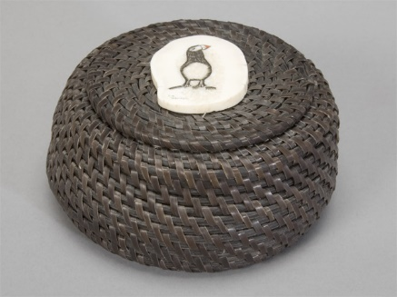
1 image is copyright protected available only online
WALRUS
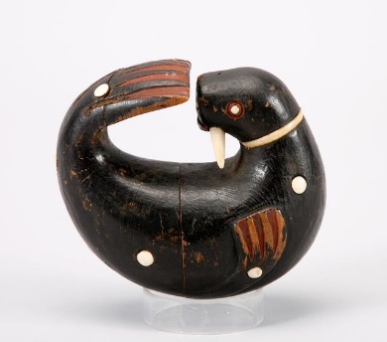
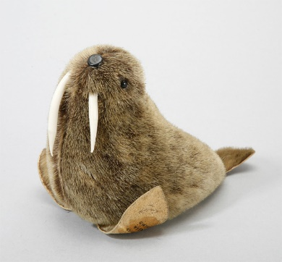
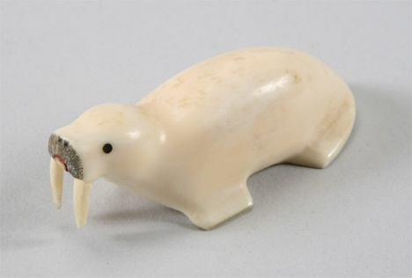

POLAR BEAR
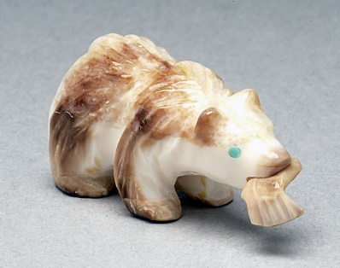
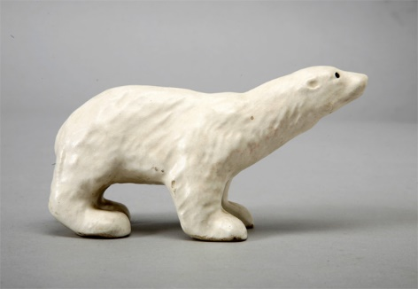
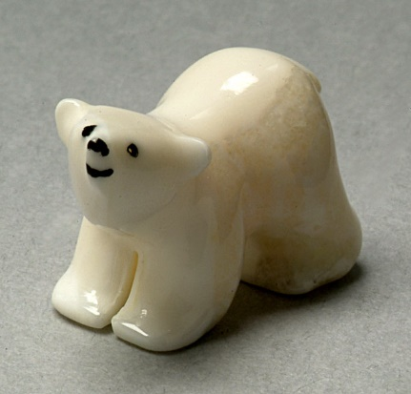
ARTIC FOX
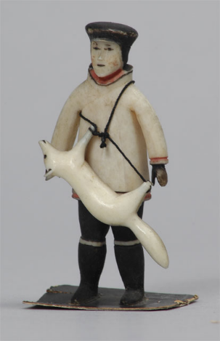
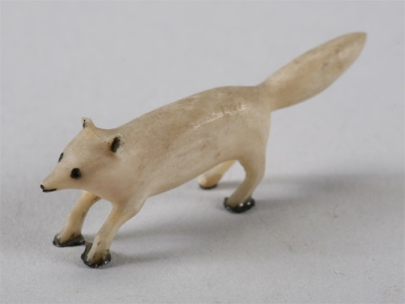
ELK
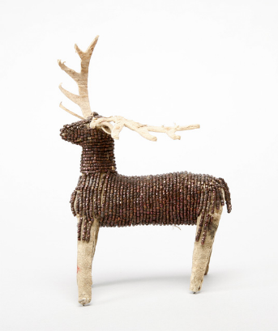
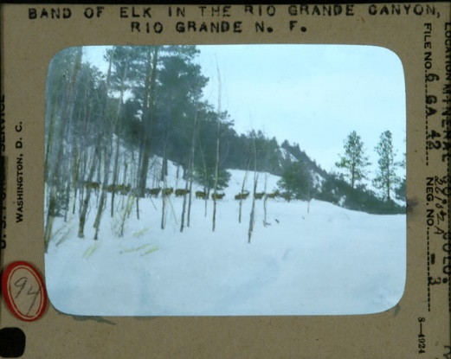
SEA LION
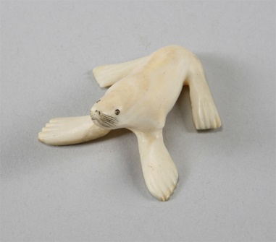
CARIBOU
1 image is copyright protected available only online
SEAL
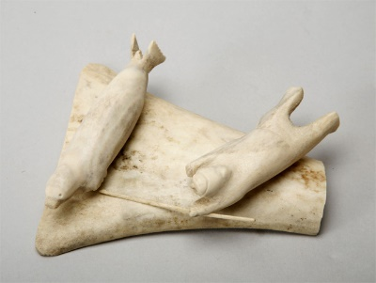
SNOW OWL
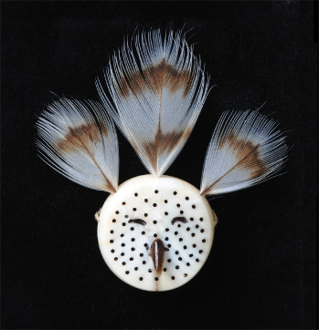
BEAR
REINDEER
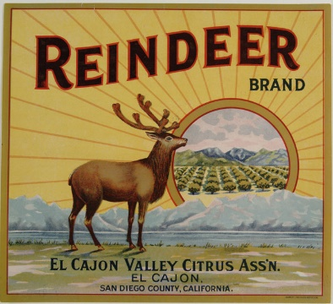
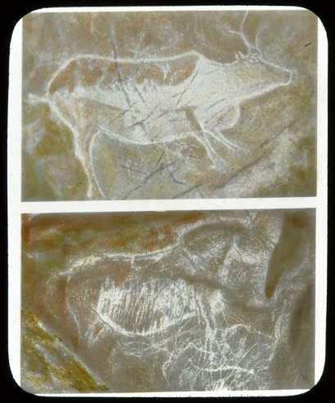
HORSE
