Mexico’s boundaries and names have changed throughout time. The Aztecs first used the word “Mexico” in their nahuatl language when they established their empire in the 13th century. Spanish colonizers called their conquered territory “New Spain” and controlled the area between 1519 and 1821. Mexico won its sovereignty in 1821 and comprised a geographic, ethnic, and economic diverse nation that included present-day California, Nevada, Arizona, New Mexico, Utah, Colorado, Texas, and Wyoming. The 1845 annexation of Texas led to the Mexican-American War and the 1848 Treaty of Guadalupe Hidalgo, forcing Mexico to lose almost one-half of its land—an area larger than the Louisiana Purchase. Mexicans living in what was now the United States were given a choice of continuing to live on their land and be granted full rights as citizens of the United States or move to what was now Mexico. However, those who decided to stay and become U.S. citizens eventually found that their rights and equality were almost immediately called into question and land titles held by former Mexicans were taken away.

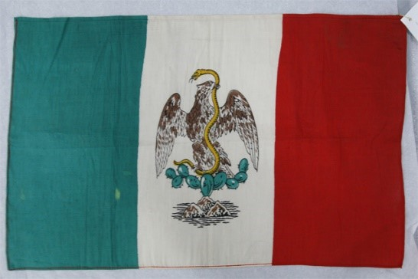
http://collections.theautry.org/mwebcgi/mweb.exe?request=record;id=M103796;type=101
Object: Mexican flag
Date: 1920
Object ID: 79.L.34
Note: California was part of Mexico from 1832 to 1849.

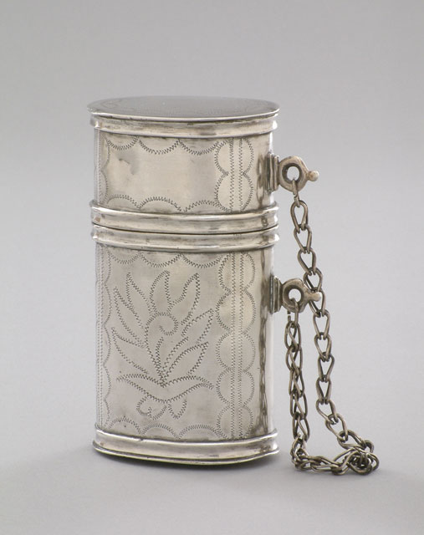
http://collections.theautry.org/mwebcgi/mweb.exe?request=record;id=M548145;type=101
Object: Tobacco box
Date: Eighteenth century to early nineteenth century
Object ID: 88.127.67
Notes: Silver tobacco box with stamped floral designs; typical of those used by gentlemen in Taos, New Mexico.
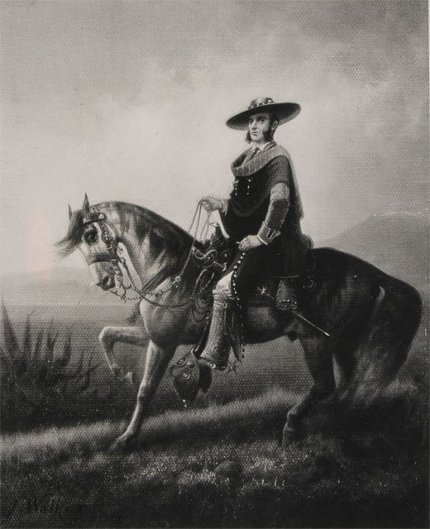
http://collections.theautry.org/mwebcgi/mweb.exe?request=record;id=M33959;type=102
Object: Photograph
Maker: J. Walker and John Dewar
Title: Painting Portrait of a Californio Land Owner
Object ID: P.41749A
Notes: Californios were Spanish-speaking residents of Spanish California (1769–1832) and Mexican California (1832–1848).

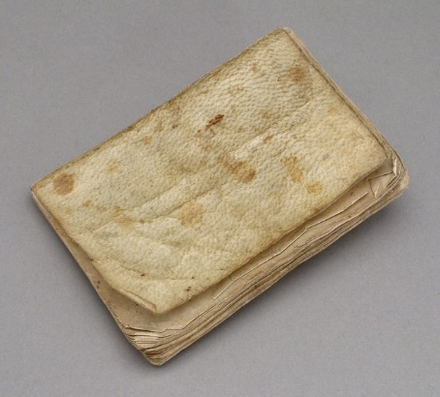
http://collections.theautry.org/mwebcgi/mweb.exe?request=record;id=M559713;type=106
Object: Book
Title: Catecismo y Esposicion Breve de la Doctrina Cristiana (Spanish-language catechism).
Date: 1819
Object ID: 93.21.160
Notes: Mexican California had no regular schools, and many people could not read. In 1819, the commander of the Santa Barbara presidio, José de la Guerra, ordered catechisms from Mexico like this one, along with primers, notebooks and paper. A local woman was hired to teach school, and parents contributed to her salary.

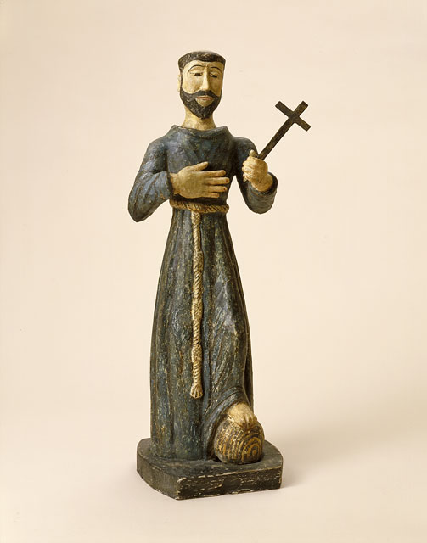
http://collections.theautry.org/mwebcgi/mweb.exe?request=record;id=M530161;type=101
Object: Bulto
Maker: Arroyo Hondo Carver
Title: Untitled (San Francisco)
Date: Circa 1830–1845
Object ID: 90.209.1
Notes: Bultos are carvings of saints made out of wood and painted with bright colors. Bultos were historically created in the Southwestern United States in the eighteenth and nineteenth centuries. This piece is attributed to Arroyo Hondo santero (a maker of santos) who worked in the rural communities around Taos.

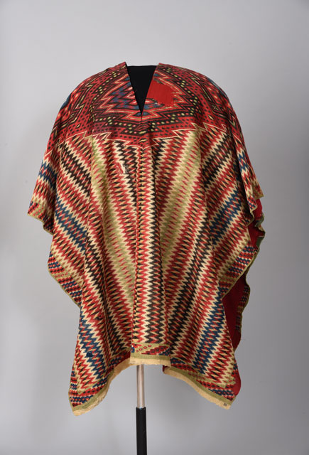http://collections.theautry.org/mwebcgi/mweb.exe?request=record;id=M559896;type=101
Object: Serape
Date: Mid-to late 1800s
Object ID: 93.21.14
Notes: Belonged to California Governor Pio Pico. Saltillo serapes were detailed, and tightly woven cloaks or ponchos made for wealthy landowners in Mexico. Saltillo weavings became a source of national pride in Mexico and were imitated by weavers in New Mexico.
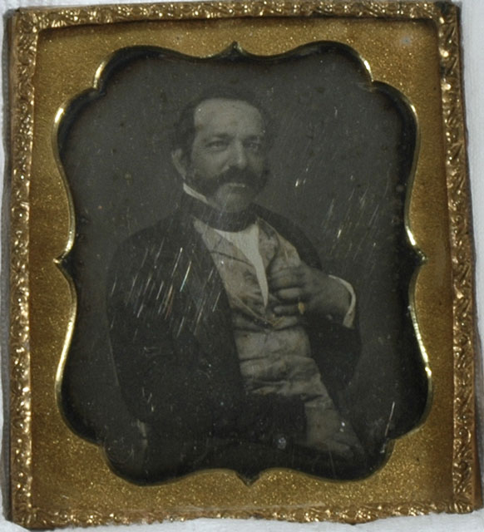
http://collections.theautry.org/mwebcgi/mweb.exe?request=record;id=M55385;type=102
Object: Daguerreotype
Maker: Unidentified photographer
Title: Andrés Pico
Date: 1800s
Object ID: 34.G.141
Notes: Daguerreotype portrait of Andrés Pico, Los Angeles, California. He led the Mexican army in California against the United States in the Mexican-American War.

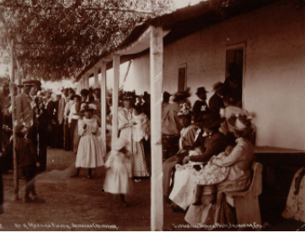http://collections.theautry.org/mwebcgi/mweb.exe?request=record;id=M19498;type=102
Object: Photograph
Maker: George Wharton James
Title: At a Mexican Fiesta
Date: Circa 1880
Object ID: P.13250
Notes: Photograph of a Mexican Fiesta in San Juan Capistrano, California, circa 1880.
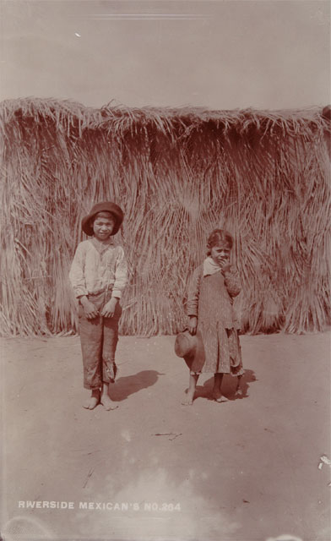
http://collections.theautry.org/mwebcgi/mweb.exe?request=record;id=M26191;type=102
Object: Photograph
Maker: George Wharton James
Title: Mexican Children at Riverside, California
Date: Late 1800s
Object ID: P.14495

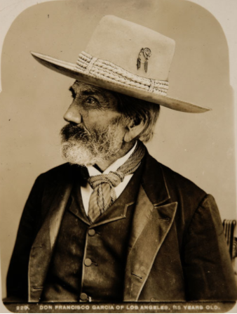http://collections.theautry.org/mwebcgi/mweb.exe?request=record;id=M29885;type=102
Object: Photograph
Maker: Charles Chester Pierce
Title: A Portrait of Don Francisco Garcia
Date: circa 1890
Object ID: P.15382
Notes: Photograph portrait of Don Francisco Garcia, Los Angeles, California, circa 1890. Caption: "Don Francisco Garcia of Los Angeles, 115 years old.”
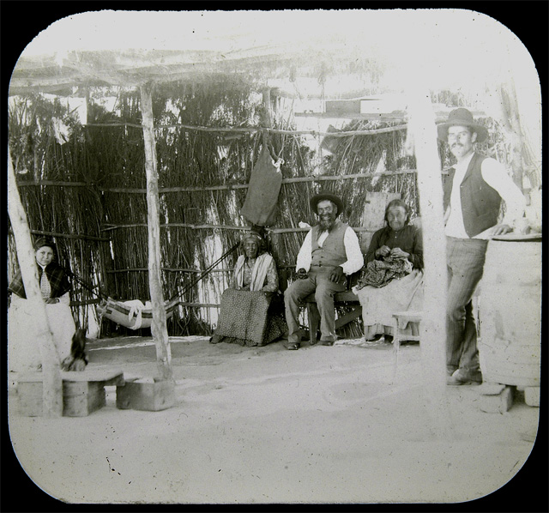http://collections.theautry.org/mwebcgi/mweb.exe?request=record;id=M291264;type=102
Object: Lantern slide
Maker: George Wharton James
Title: Mexican Domestic Contentment
Date: Circa 1885–1901
Object ID: LS.5546
Notes: Lantern slide of a group of Mexican men.

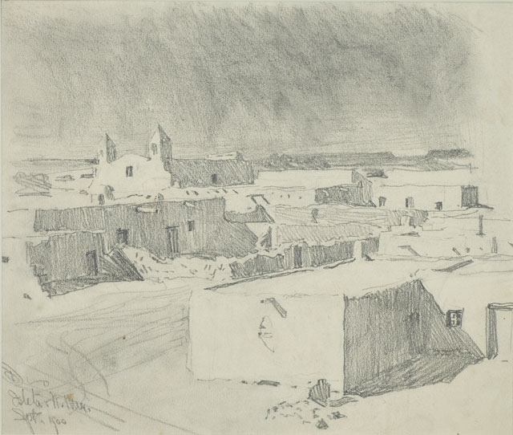
http://collections.theautry.org/mwebcgi/mweb.exe?request=record;id=M534843;type=101
Object: Drawing
Maker: Maynard Dixon
Title: Adobe Dwelling of Isleta, New Mexico
Date: September 1900
Object ID: 93.35.1
Notes: Pencil on paper drawing by Maynard Dixon.
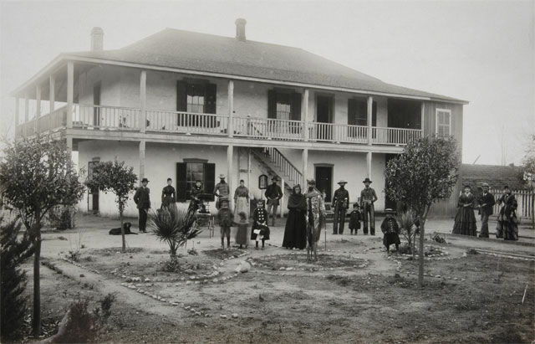
http://collections.theautry.org/mwebcgi/mweb.exe?request=record;id=M39196;type=102
Object: Photograph
Maker: C. J. Crandall
Date: Early to mid-1900s
Object ID: P.17432
Notes: Photograph of family of Antonio Maria Lugo in front of his adobe at Rancho San Antonio, California, early to mid-1900s. Handwritten caption on back, “The Lugo Ranch House near Los Angeles. A two-story adobe with outside/verandas and staircase—a type often build by Spanish Californians.”

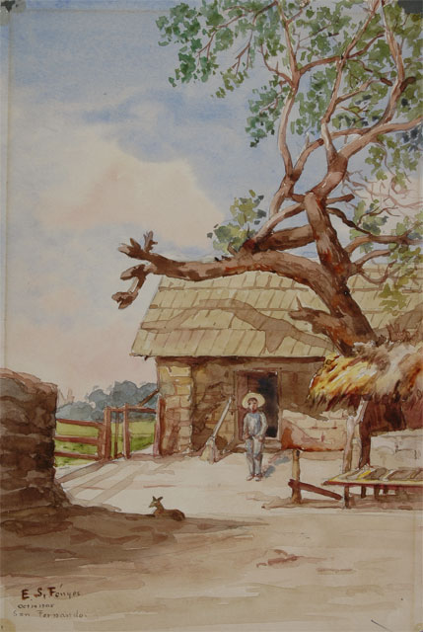
http://collections.theautry.org/mwebcgi/mweb.exe?request=record;id=M130295;type=101
Object: Painting
Maker: Eva Scott Fenyes
Title: The Fernando Morales Adobe, at San Fernando, California
Date: 1905
Object ID: FEN.211
Notes: Handwritten caption on back, “The boy who stands before the door is a Mexican lad who helps Morales take care of the mission property.” Missions in California were secularized (made non-religious) by the Mexican government in 1833 and the land was sold off as ranchos.

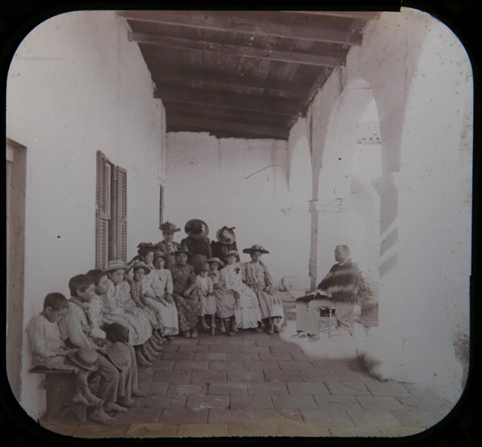
http://collections.theautry.org/mwebcgi/mweb.exe?request=record;id=M295347;type=102
Object Name: Lantern slide
Maker: Unidentified Photographer
Title: Class of Students at Mission San Juan Capistrano
Object ID: LS.6192
Notes: This image is of Mexican and Native American students at school at the former Mission San Juan Capistrano. After Mexican secularization of the missions (making them non-religious), while some were sold off as privately-owned ranchos, others became Catholic churches for worship and schools for Mexican communities. Many local Native American children were forced to attend school.

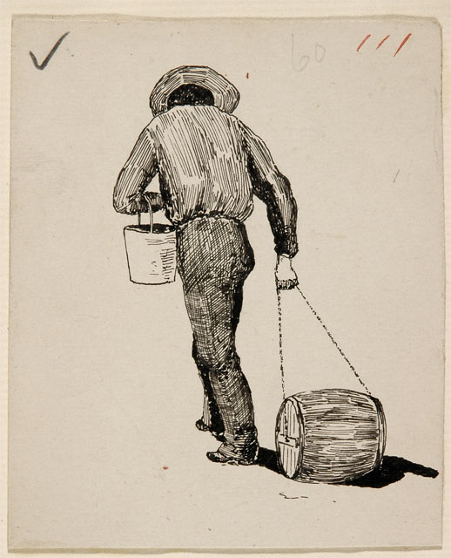
http://collections.theautry.org/mwebcgi/mweb.exe?request=record;id=M217006;type=101
Object: Drawing
Maker: Carl Eytel
Title: Mexican Hauling Water at Mexicali
Date: 1900–1906
Object ID: EYTEL.39.151
Notes: Ink on paper drawing by Carl Eytel.
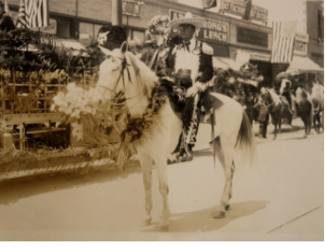http://collections.theautry.org/mwebcgi/mweb.exe?request=record;id=M31355;type=102
Object Name: Photograph
Maker: Warren C. Dickerson.
Title: A Mexican Horseman at Fiesta De Los Angele.
Date: 1907
Object ID: P.15770
Notes: Photograph of a Mexican horse rider at La Fiesta de Los Angeles, California.

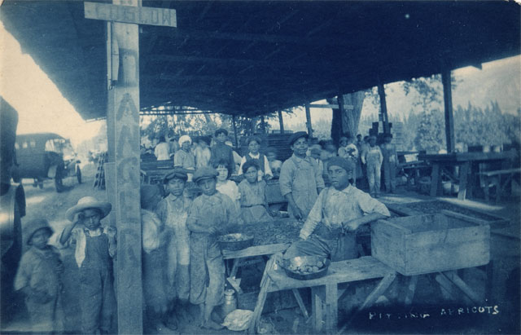
http://collections.theautry.org/mwebcgi/mweb.exe?request=record;id=M29679;type=102
Object Name: Photograph
Maker: Charles Fletcher Lummis
Title: Apricot Sorters and Packers
Date: Early 1900s
Object ID: P.15327
Notes: Handwritten caption on back, “Apricot packers, immigrant [sic] Mexican workers.”

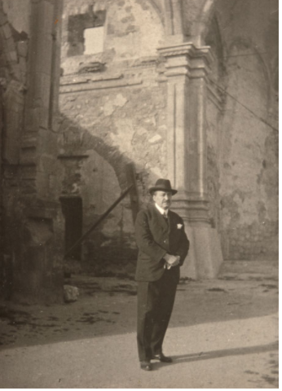http://collections.theautry.org/mwebcgi/mweb.exe?request=record;id=M98374;type=102
Object Name: Photograph
Maker: Unidentified Photographer
Title: Vicente Blasco Ibanez at Unidentified Mission Ruins
Date: Circa 1920
Object ID: P.32400
Notes: Handwritten caption on back, “With love to Uncle Charlie from his niece Virginia.”

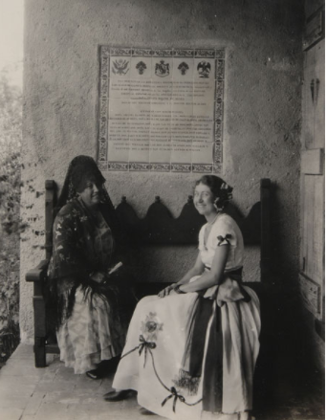http://collections.theautry.org/mwebcgi/mweb.exe?request=record;id=M307086;type=102
Object Name: Photograph
Date: 1931
Object ID: S5.123
Notes: Photograph of Florence Schoneman and Marion Parks sitting below the tile plaque commemorating Henry Willliam O'Melveny at the Casa de Adobe, Los Angeles, California, July 1931. Handwritten caption on back: “Mrs. Florence de Schoneman and Miss Marion Parks at Casa Adobe before Hispanic tablet.”

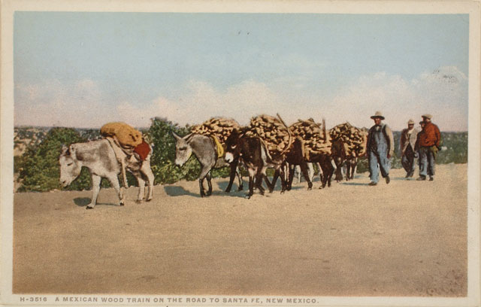
http://collections.theautry.org/mwebcgi/mweb.exe?request=record;id=M558503;type=102
Object Name: Postcard
Maker: Detroit Publishing Company
Title: A Mexican Wood Train on the Road to Santa Fe, New Mexico
Date: Circa 1930
Object ID: 89.119.36

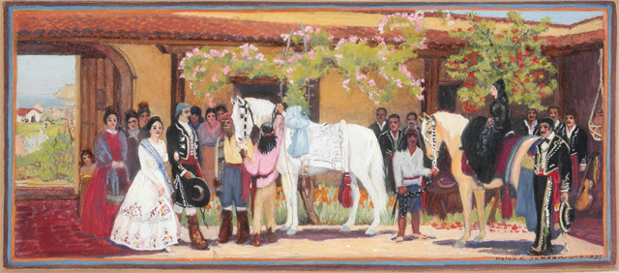
http://collections.theautry.org/mwebcgi/mweb.exe?request=record;id=M298547;type=101
Object Name: Painting
Maker: Helen Jordan
Title: The Wedding
Date: 1937
Object ID: 14.C.19
Notes: Painting completed under the Works Progress Administration, job number 282.

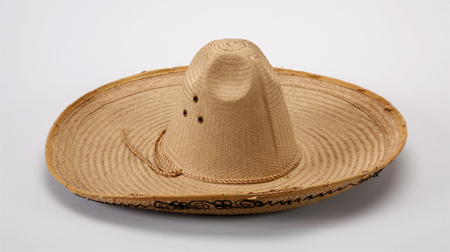http://collections.theautry.org/mwebcgi/mweb.exe?request=record;id=M190073;type=101
Object Name: Hat
Maker: Unknown
Date: 1956–1960
Object ID: 1.A.104
Notes: Straw hat
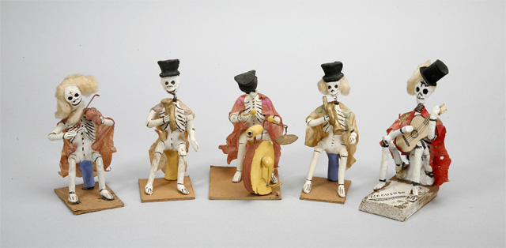http://collections.theautry.org/mwebcgi/mweb.exe?request=record;id=M210193;type=101
Object Name: Figure
Maker: Unknown
Date: 1956–1960
Object ID: 564.G.14A
Notes: Skeleton band figurines

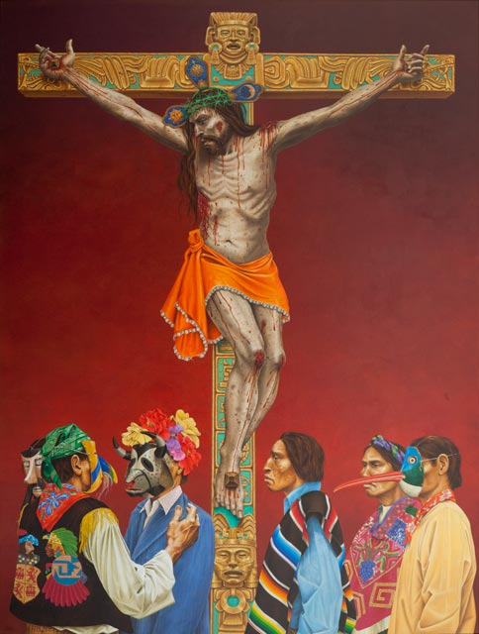http://collections.theautry.org/mwebcgi/mweb.exe?request=record;id=M624233;type=101
Object Name: Painting
Maker: Paul Pletka
Title: Tears of the Lord
Date: 2005
Object ID: 2012.17.1
Notes: Fascinated by Native and Hispanic cultures since childhood, Paul Pletka's work looks at the mingling and clashes that happen when Christianity is imposed upon Indigenous peoples. The figure of Christ is shown nailed to an Aztec cross. At his feet a group of Mexican people wear a combination of traditional and contemporary dress, which in turn reflects both Indigenous and Western designs.

