In 1848, James Marshall discovered gold at Sutter’s Mill in Coloma, California, which is about 140 miles northeast from San Francisco. As the world learned of the discovery, thousands of people traveled to California from Asia, South America, Europe, and across North America to strike it rich. Most miners were unsuccessful, but the gold rush’s impact can still be felt today in the violence experienced by California’s Native communities and the environment in northern California.

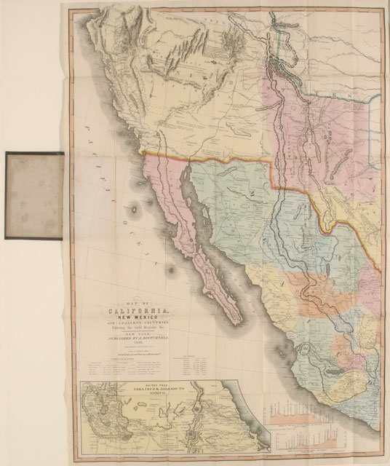
http://collections.theautry.org/mwebcgi/mweb.exe?request=record;id=M535518;type=103
Object Name: Map
Maker: J. Disturnell
Title: Map of California, New Mexico and Adjacent Countries Showing The Gold Regions & c.
Date: 1849
Object ID: 90.253.284
Notes: Color map of California and New Mexico detailing routes and topographic information.

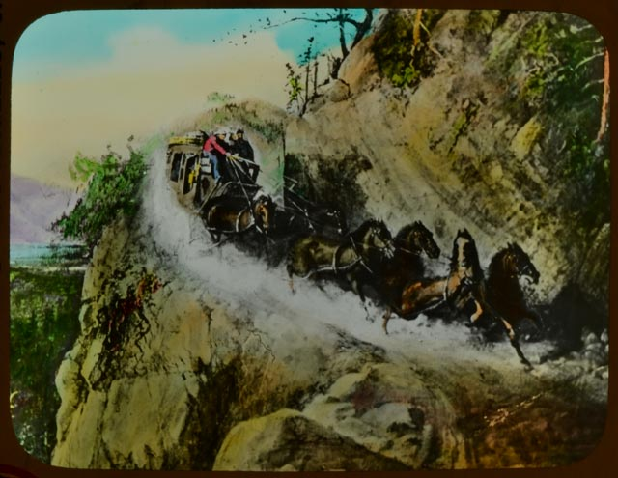
http://collections.theautry.org/mwebcgi/mweb.exe?request=record;id=M302266;type=102
Object Name: Lantern slide
Title: Crossing the Sierras in '49
Object ID: LS.7260
Notes: Lantern slides are photographs made on glass and viewed with an early version of a projector.

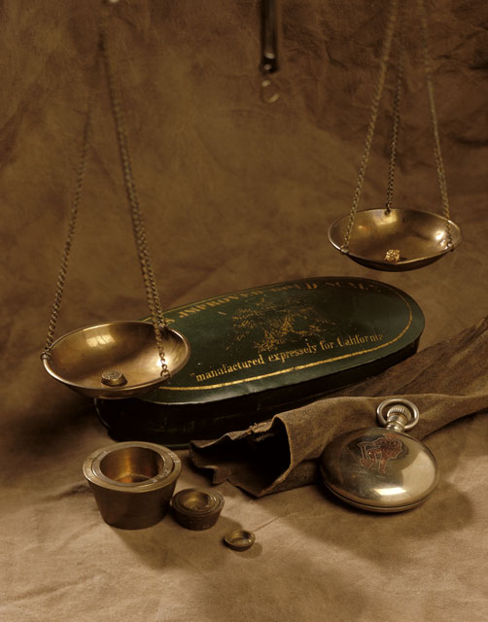
http://collections.theautry.org/mwebcgi/mweb.exe?request=record;id=M505633;type=101
Object Name: Scale
Date: 1849–1855
Object ID: 93.21.20
Notes: Portable gold scale, typical of those used during the gold rush. Scales like this were commonly carried by miners.

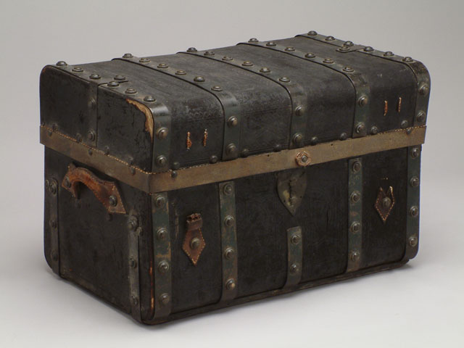
http://collections.theautry.org/mwebcgi/mweb.exe?request=record;id=M534658;type=101
Object Name: Trunk
Date: circa 1849
Object ID: 89.175.1
Notes: Leather-covered wood trunk lined with removable drawer.

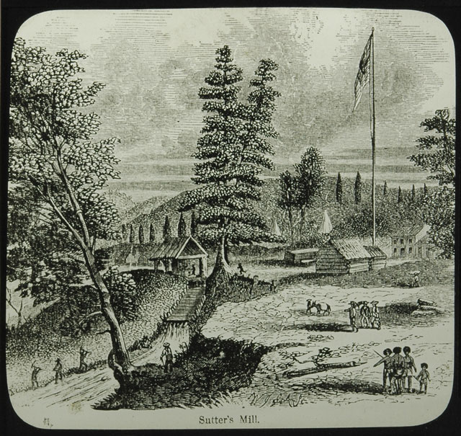
http://collections.theautry.org/mwebcgi/mweb.exe?request=record;id=M276103;type=102
Object Name: Lantern slide
Maker: Unidentified artist
Title: Sutter’s Mill on January 24, 1848
Date: late 1800s to early 1900s
Object ID: LS.2832
Notes: Lantern slide of a drawing featuring Sutter’s Mill in Coloma, California.

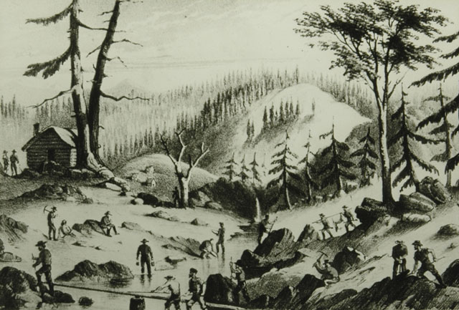
http://collections.theautry.org/mwebcgi/mweb.exe?request=record;id=M276158;type=102
Object Name: Lantern slide
Maker: E.W. Kain
Title: Where the Gold Comes From
Date: late 1800s to early 1900s
Object ID: LS.2845
Notes: Lantern slide of a drawing of gold miners working in northern California.

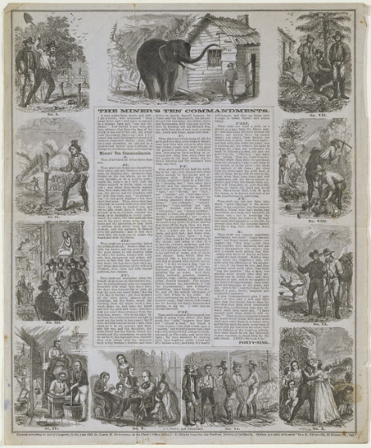
http://collections.theautry.org/mwebcgi/mweb.exe?request=record;id=M505833;type=105
Object Name: Lettersheet
Maker: James Mason Hutchings
Title: The Miner’s Ten Commandments
Date: 1853
Object ID: 89.212.11
Notes: A lettersheet is a piece of paper that can be folded, sealed, and mailed without the need to use an envelope.

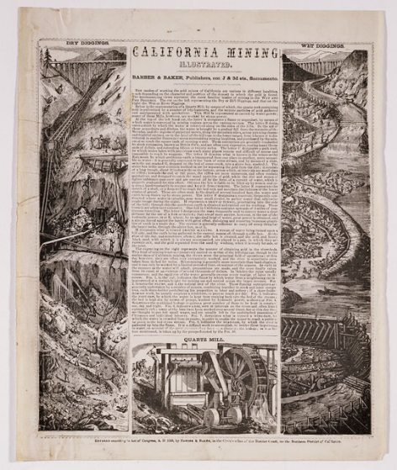
http://collections.theautry.org/mwebcgi/mweb.exe?request=record;id=M549083;type=105
Object Name: Lettersheet
Maker: Barber & Baker, Publishers
Title: California Mining Illustrated
Date: 1855
Object ID: 94.237.15
Notes: On the left side of the page are drawings featuring men digging and using hydraulics to clear out a mine. On the right side of the page are drawings featuring men working along a riverbed.

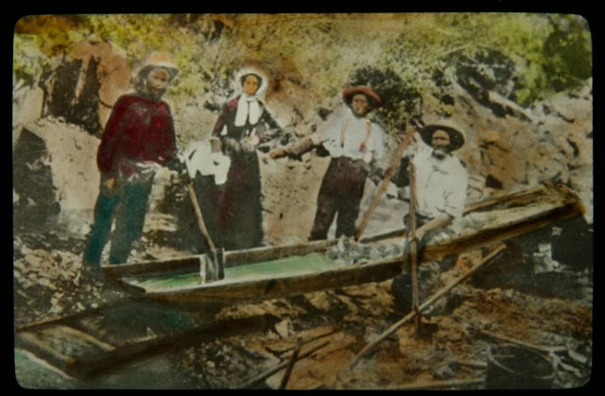
http://collections.theautry.org/mwebcgi/mweb.exe?request=record;id=M2853;type=102
Object Name: Lantern slide
Maker: F.H. Maude
Title: A Group of Miners with Sluice Box
Object ID: LS.9444
Note: A sluice is a long narrow box that traps gold as water passes through it.

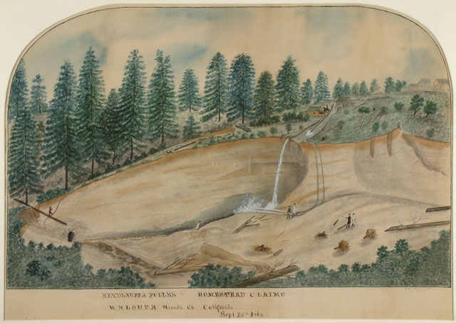
http://collections.theautry.org/mwebcgi/mweb.exe?request=record;id=M560587;type=101
Object Name: Painting
Maker: George Barrington
Title: Heydluff & Fuller on Homestead Claims, Waloupa Nevada Co. California, Sept. 25th, 1860
Date: September 25, 1860
Object ID: 87.87.10
Note: Landscape scene of hydraulic gold mining operation. Hydraulic mining used hoses of water to wash away hillsides to find gold.

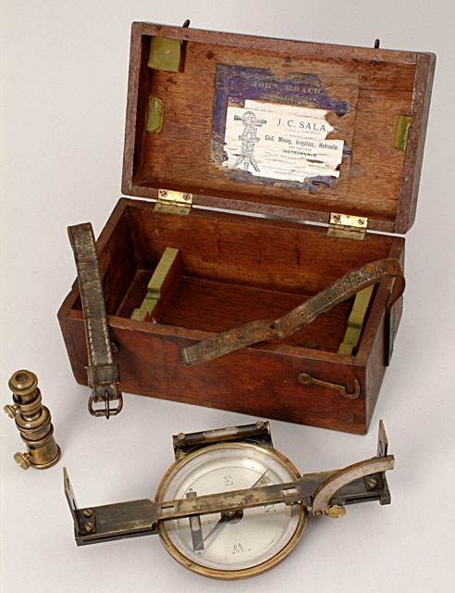
http://collections.theautry.org/mwebcgi/mweb.exe?request=record;id=M544873;type=101
Object Name: Compass
Maker: John Roach
Date: 1850s
Object ID: 95.152.1
Notes: A compass made for surveying mine shafts.

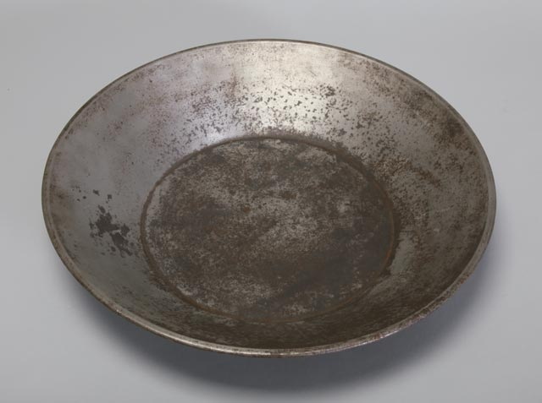
http://collections.theautry.org/mwebcgi/mweb.exe?request=record;id=M535555;type=101
Object Name: Gold pan
Date: 1880s
Object ID: 85.1.737
Notes: Metal pan used for mining gold.

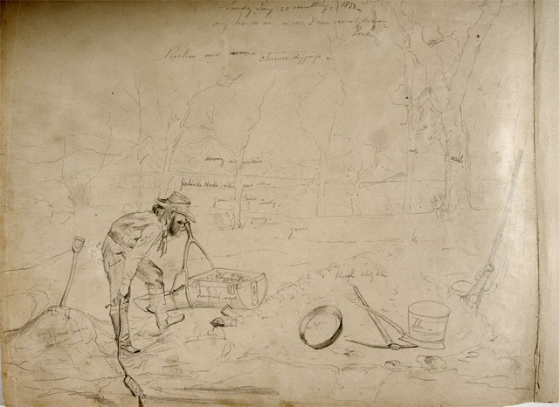
http://collections.theautry.org/mwebcgi/mweb.exe?request=record;id=M26438;type=101
Object Name: Drawing
Maker: John Woodhouse Audubon
Title: Chinese Diggings
Date: January 20, 1850
Object ID: 22.G.978K
Notes: Pen and ink drawing of a gold miner.

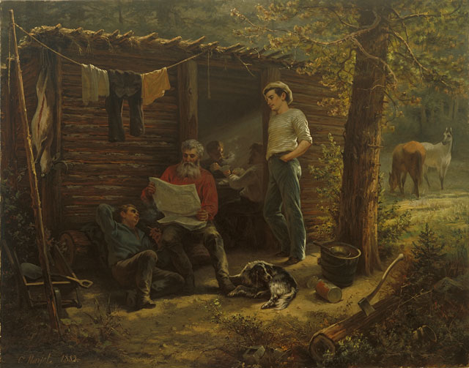
http://collections.theautry.org/mwebcgi/mweb.exe?request=record;id=M512880;type=101
Object Name: Painting
Maker: Erneste E. Narjot
Time: Miners: A Moment at Rest (Gold Rush Camp)
Date: 1882
Object ID: 97.88.1
Notes: Painting featuring three men and a dog resting around a cabin.

