Around 2,000 Native American tribes lived in present-day California thousands of years before Spanish soldiers and missionaries began arriving in the mid-1530s. The descendants of Spanish and Mexican families living in California were called Californios, and by the time California became a state in 1850, there were 14,000 Californios living in California. African people arrived in California with the Spanish in the mid-1500s, most without choice. The 1848 Gold Rush brought to California an estimated 300,000 people from across North America, as well as from China, South America, and Europe.
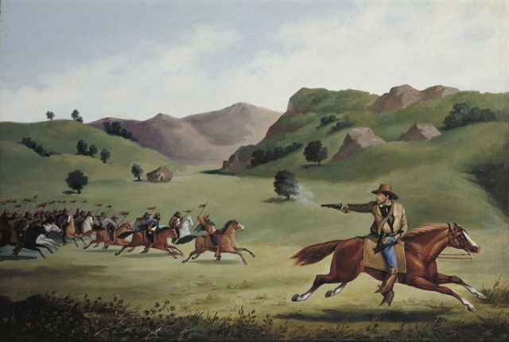
http://collections.theautry.org/mwebcgi/mweb.exe?request=record;id=M514879;type=101
Object Name: Painting
Maker: Alexander Edouart
Title: The Chase
Date: 1857
Object ID: 92.33.1
Notes: Painting depicts Henry L. Ford, a captain in General John Frémont's California Battalion, being chased by Californio lancers during the war in California. Ford took part in the 1846 Bear Flag Revolt at Sonoma and in 1857 commissioned San Francisco artist Alexander Edouart to paint several scenes recalling his adventures.

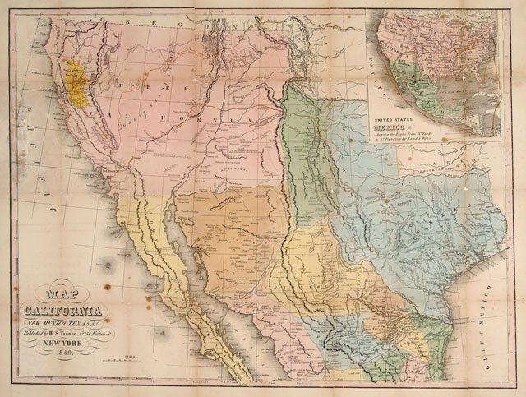http://collections.theautry.org/mwebcgi/mweb.exe?request=record;id=M567232;type=103
Object name: Map
Maker: H.S. Tanner
Title: Map of California, New Mexico, Texas & C.
Date: 1849
Object ID: 99.65.1
Notes: This map shows land and water routes from New York to San Francisco, detailing the territories gained during the war with Mexico.

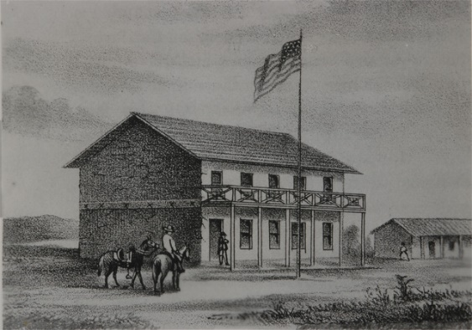
http://collections.theautry.org/mwebcgi/mweb.exe?request=record;id=M123291;type=102
Object Name: Photograph
Maker: Unidentified artist
Title: The First Capitol of the State of California at San Jose
Date: circa 1849
Object ID: P.38669
Notes: This is a photograph of the drawing of the first capitol building of the state of California. The building was originally constructed as a hotel; the first California legislature met there to conduct the business of the new state.

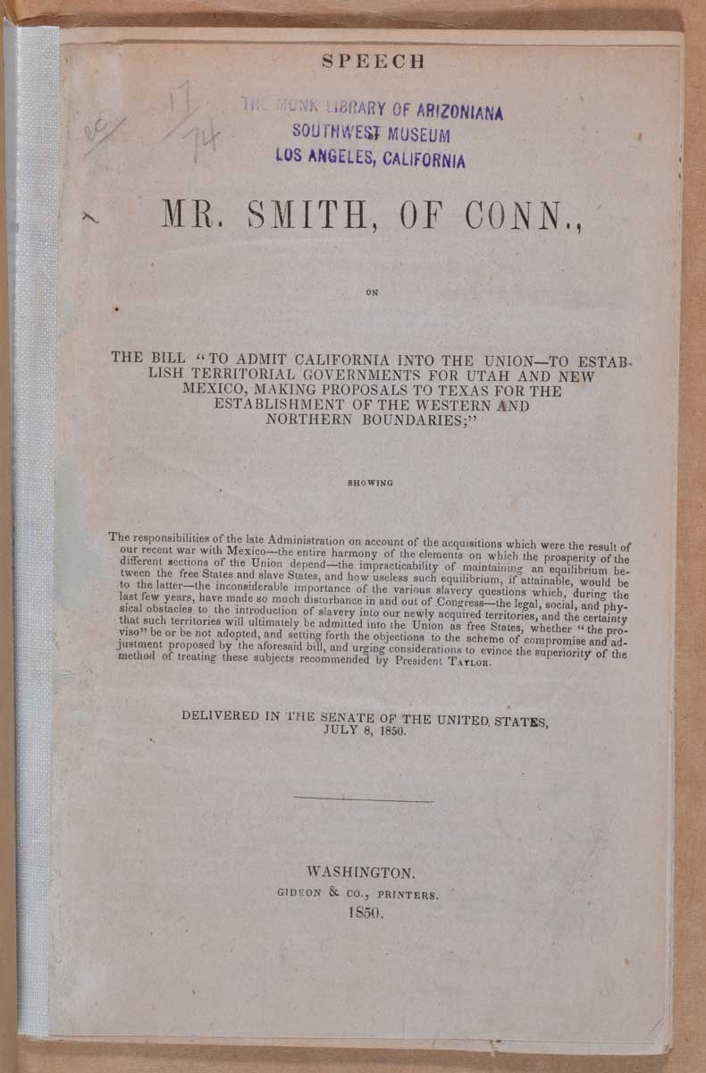
http://collections.theautry.org/mwebcgi/mweb.exe?request=record;id=M65964;type=102
Object Name: Speech
Maker: Gideon and Co., Printers
Title: “Speech of Mr. Smith, of Conn., on the Bill ‘To Admit California into the Union--to Establish Territorial Governments for Utah and New Mexico, Making Proposals to Texas for the Establishment of the Western and Northern Boundaries’”
Date: July 8, 1850
Object ID: M.978.16
Notes: This is a printed copy of the speech given by Senator Truman Smith (Whig party, Connecticut). In this speech, Senator Truman discusses the question of whether to admit California to the United States.

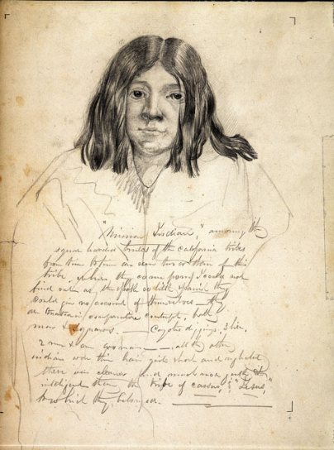http://collections.theautry.org/mwebcgi/mweb.exe?request=record;id=M26491;type=101
Object Name: Drawing
Maker: John Woodhouse Audubon
Title: The Mission Indian
Date: 1849-1851
Object ID: 22.G.978U
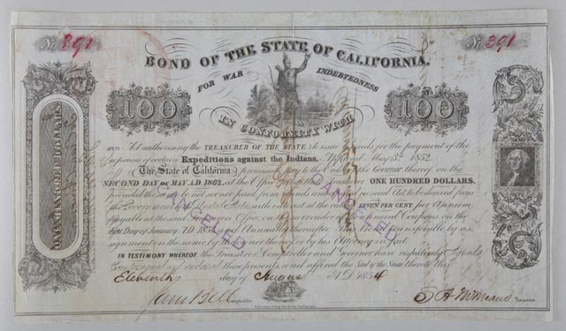http://collections.theautry.org/mwebcgi/mweb.exe?request=record;id=M592628;type=105
Object name: Bond
Maker: Unknown publisher
Date: 1854
Object ID: 2003.85.1
Notes: Bond of the State of California, paid and canceled, number 391, for $100, issued for "Expeditions against the Indians," August 11, 1852. In 1852 the California state legislature authorized $600,000 in bonds to pay for “expeditions against the Indians.” Volunteer militia attacked Native communities and families, pursuing a strategy of genocide, and escalating the kidnapping and indenture of Native children.

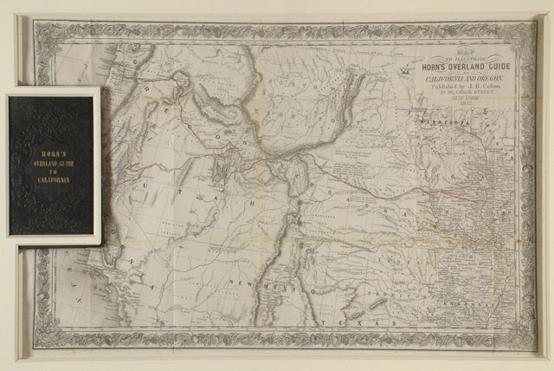
http://collections.theautry.org/mwebcgi/mweb.exe?request=record;id=ocn166480766;type=106
Object name: Map
Maker: Hosea B. Horn, J.H. Colton
Title: Horn’s overland guide to California
Date: 1852
Object ID: 90.253.313
Notes: Map created by Hosea B. Horn, detailing prominent landmarks between Council Bluffs, Iowa, and Sacramento, California. Horn even noted where travelers could find firewood for their campfires and which forts offered goods for trade.
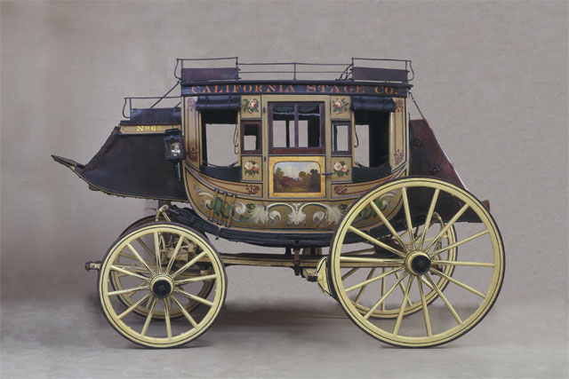http://collections.theautry.org/mwebcgi/mweb.exe?request=record;id=M549221;type=101
Object name: Stagecoach
Maker: Abbot and Downing Company
Date: 1850s
Object ID: 93.21.261
Notes: This stagecoach was built around 1855 by Lewis Downing in Concord, New Hampshire. It was part of the fleet drive on the California Stage Company line. The roof of the coach held luggage or additional passengers. Teams of four to six horse powered the coach, managed by a driver with a guard seated next to him.
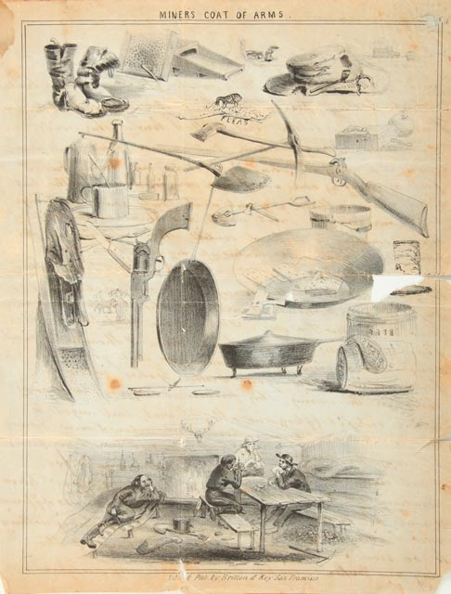http://collections.theautry.org/mwebcgi/mweb.exe?request=record;id=M588456;type=105
Object name: Lettersheet
Maker: Britton & Ray
Date: 1854
Object ID: 2003.47.1
Notes: Lettersheet, illustrated with print of Miner's Coat of Arms in black. The drawings included depictions from a miner’s life, pieces of worn clothing, boots with holes, tools, miners playing cards at night, and fleas.
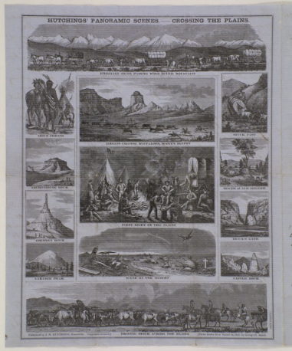http://collections.theautry.org/mwebcgi/mweb.exe?request=record;id=M530920;type=105
Object name: Lettersheet
Maker: George H. Baker, James Mason Hutchings
Title: Hutchings' Panoramic Scenes—Crossing the Plains
Date: 1853
Object ID: 94.237.12
Notes: One side features 13 small black and white vignettes, such as wagons crossing the Plains, natural features in the Western landscape, and night life at camp. The other side features a letter written by a man named Edward to his sister, Eliza. The letter, which is dated January 30, 1855, details Edward’s life in California.
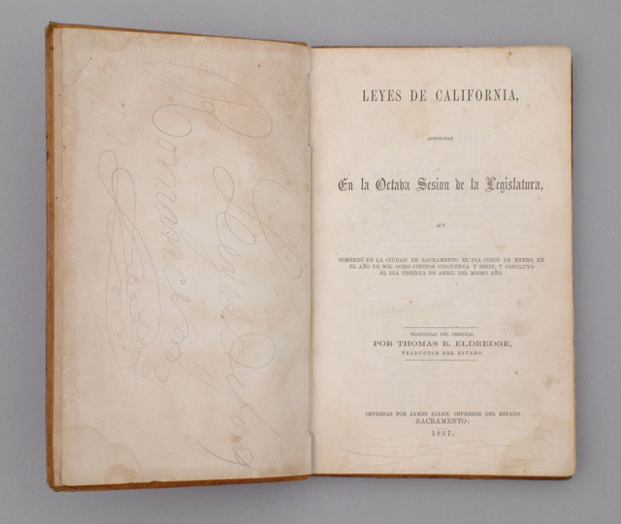
http://collections.theautry.org/mwebcgi/mweb.exe?request=record;id=M513467;type=106
Object Name: Book
Maker: Thomas R. Eldredge
Title: Leyes de California aprobadas En la Octaba Sesion de la Legislatura (Laws of California, Approved in the October Session of the Legislature)
Date: 1857
Object ID: 90.253.297
Notes: This book published all the laws passed by the California Legislature during its October 1857 session. According to the 1850 state constitution, all laws had to be translated and published in both Spanish and English. By the 1880s, this law had been changed, and the California state government was no longer bilingual.
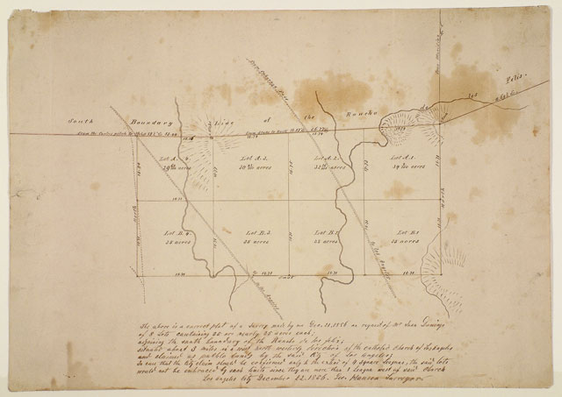
http://collections.theautry.org/mwebcgi/mweb.exe?request=record;id=M549779;type=103
Object Name: Map
Maker: George Mansen
Title: Southern Boundary of Rancho de Los Feliz
Date: December 22, 1856
Object ID: 98.91.2
Notes: Hand drawn map of eight lots adjoining the south boundary of Rancho de Los Feliz. Surveyed by George Mansen at the request of Mr. Juan Domingo, dated December 22, 1856, Los Angeles City.

