Geography played a key role in defining African American communities in the West of 1890. In Texas and Indian Territory, African Americans struggled to overcome a history of slavery. In Kansas, Nebraska, and the Oklahoma Territory, rural communities formed, eager to escape the legacy of the South and its racial barriers. The desire for better opportunities and the hope of an end to discrimination helped distinguish these new communities. In such cities as El Paso, Denver, Oakland, and Los Angeles, railroads provided employment and aided the formation of urban neighborhoods.
Object images and descriptions are on next page with hyperlinks to the objects on Autry Collections.

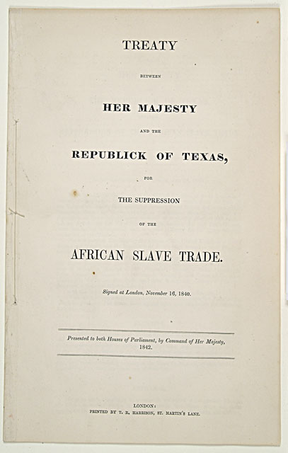
http://collections.theautry.org/mwebcgi/mweb.exe?request=record;id=M504244;type=105
Object: Treaty
Maker: T.S. Harrison
Title: Treaty between Her Majesty and the Republick [sic] of Texas, For the Suppression of the African Slave Trade
Date: 1842
Object ID: 98.12.3
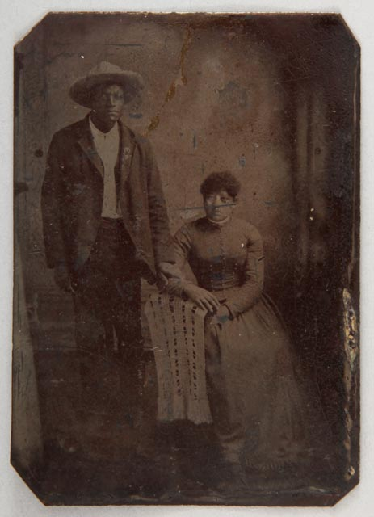
http://collections.theautry.org/mwebcgi/mweb.exe?request=record;id=M508816;type=102
Object: Tintype
Maker: N/A
Date: circa 1870s
Object ID: 93.158.3.2
Notes: Studio portrait tintype of an African-American couple, Coffeyville, Kansas. A tintype is a photograph taken on a thin piece of metal.

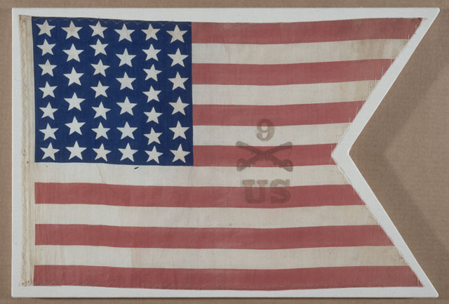
http://collections.theautry.org/mwebcgi/mweb.exe?request=record;id=M519261;type=101
Object: Flag
Maker: Unknown
Title: Parade Flag of the 9th Cavalry
Date: 1875-1900
Object ID: 2002.91.1
Notes: Flag of United States, red, white and blue cotton with thirty-nine stars, circa 1876-1900. This flag was used by the 9th U.S. Cavalry, an African American regiment in the West, as a parade flag.
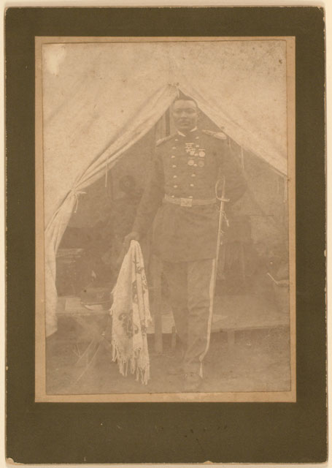
http://collections.theautry.org/mwebcgi/mweb.exe?request=record;id=M571102;type=102
Object: Photograph
Maker: United States of America
Date: circa 1886
Object ID: 2000.16.9
Notes: Albumen print photograph of William H. Franklin, a U.S. Infantry man. An albumen print is a kind of photograph made on paper that has been coated in albumen (egg white).

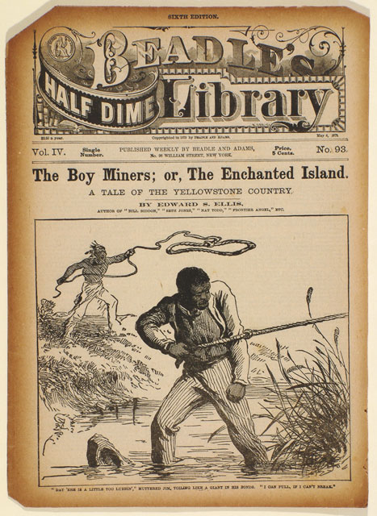
http://collections.theautry.org/mwebcgi/mweb.exe?request=record;id=M558204;type=106
Object: Dime novel
Maker: Edward S. Ellis
Title: The Boy Miners; or, The Enchanted Island: A Tale of the Yellowstone Country
Date: May 6, 1879
Object ID: 88.34.221
Notes: From Beadle’s Half-Dime Library, no. 93. Published by Beadle and Adams, New York, 1879. Dime novels were popular and inexpensive novels from the nineteenth century.
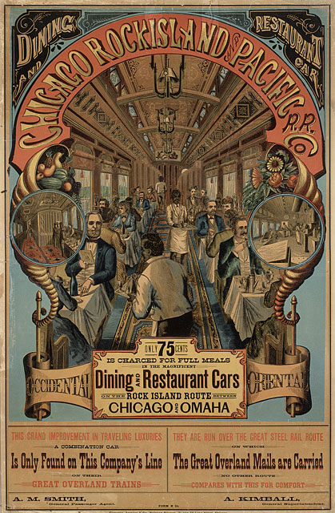
http://collections.theautry.org/mwebcgi/mweb.exe?request=record;id=M581945;type=102
Object: Poster
Maker: Cameron, Amberg and Company
Date: circa 1888
Object ID: 2002.37.1
Notes: Advertising poster for Chicago Rock Island and Pacific Railroad Company, depicting various patrons being served by African-American waiters in a dining and restaurant railroad car.
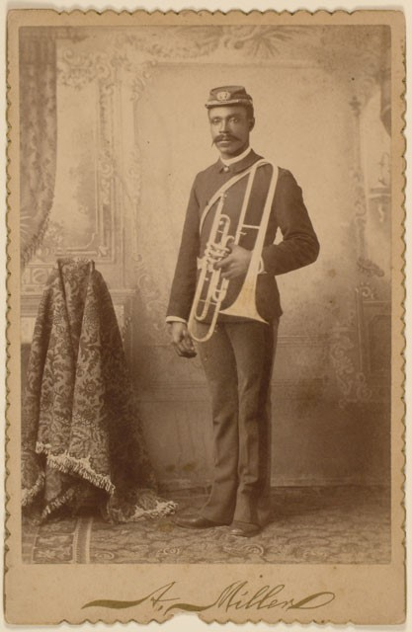
http://collections.theautry.org/mwebcgi/mweb.exe?request=record;id=M512748;type=102
Object Name: Photograph
Maker: A. Miller
Date: February 6, 1892
Title: Unknown
Object ID: 90.103.1
Notes: Cabinet card of Wesley Porter, a musician and solider in the 10th United States Cavalry, a troop of African American soldiers. A cabinet card is a photograph attached to a piece of cardboard.

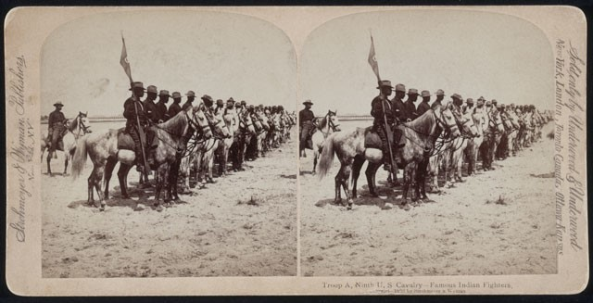
http://collections.theautry.org/mwebcgi/mweb.exe?request=record;id=M556248;type=102
Object Name: Photograph
Maker: Strohmeyer & Wyman
Date: 1898
Object ID: 93.168.2
Notes: This is a stereoview of Troop A, Ninth United States Cavalry, a troop of African American soldiers. A stereoview is a set of two nearly identical photographs.
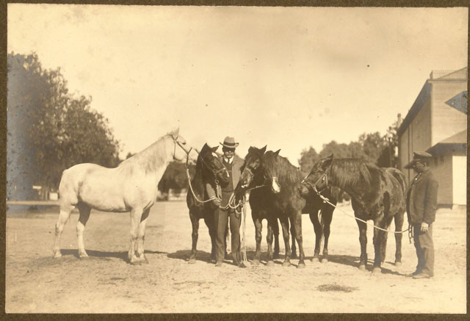
http://collections.theautry.org/mwebcgi/mweb.exe?request=record;id=M564017;type=102
Object: Photograph
Maker: Unknown
Date: early 1900s
Object ID: 88.179.102
Notes: Photograph of William F. (Doc) Carver and assistant with horses used in diving horse show.

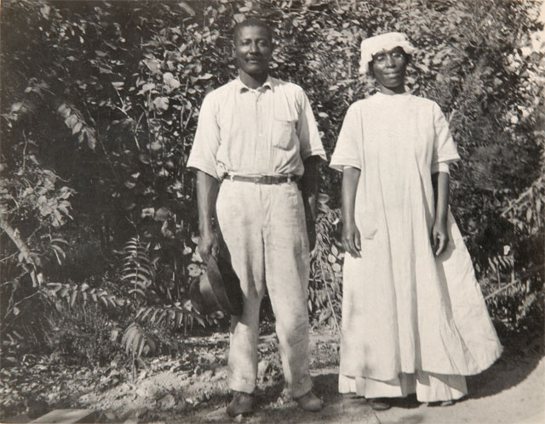
http://collections.theautry.org/mwebcgi/mweb.exe?request=record;id=M28483;type=102
Object: Photograph
Maker: Joseph Amasa Munk
Date: early 1900s
Object ID: P.14965
Notes: Photograph of a farmer and his wife in Compton, California.
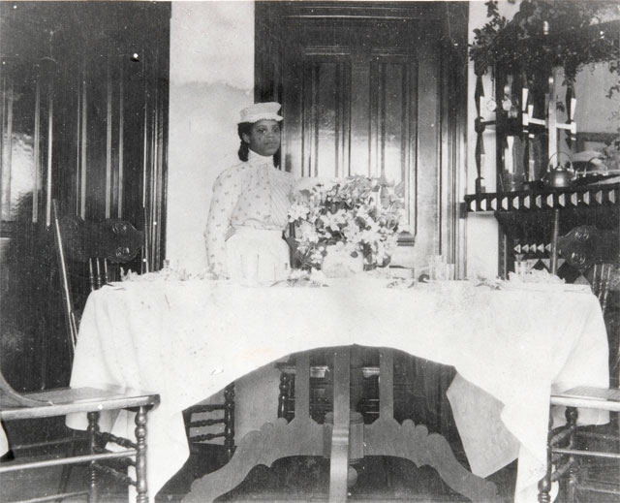
http://collections.theautry.org/mwebcgi/mweb.exe?request=record;id=M258616;type=102
Object: Photograph
Maker: Charles Fletcher Lummis
Date: circa 1904
Object ID: P.32026A
Notes: Photograph of May Ethelyn Bourne's dining room at her home, Esmeralda.

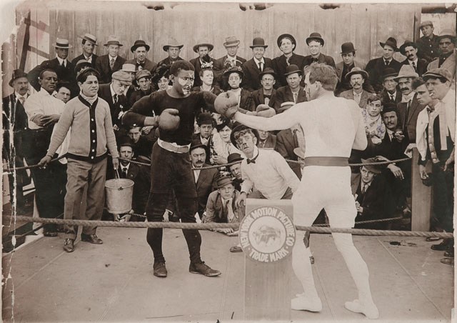
http://collections.theautry.org/mwebcgi/mweb.exe?request=record;id=M583831;type=102
Object: Photograph
Maker: Unknown
Date: 1910
Object ID: 94.36.1.158
Notes: Photograph of actors appearing in Bison Studios’ film, Dooley Referees the Big Fight (1910); directed by Fred J. Balshofer.
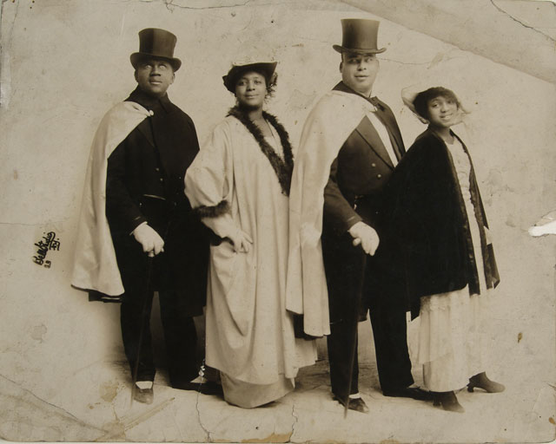
http://collections.theautry.org/mwebcgi/mweb.exe?request=record;id=M589071;type=102
Object: Photograph
Maker: The Bell Studio
Date: circa 1920
Object ID: 91.64.2
Notes: Photograph of four members from an all-Black musical band in formal attire.

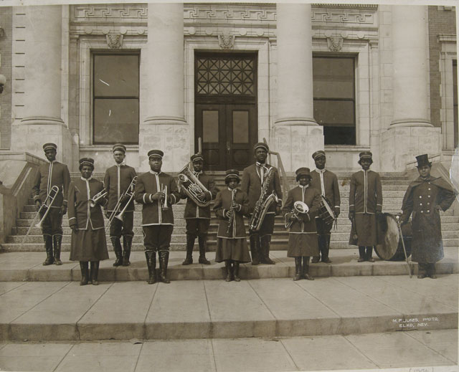
http://collections.theautry.org/mwebcgi/mweb.exe?request=record;id=M589070;type=102
Object: Photograph
Maker: M.F. Jukes
Date: circa 1920
Object ID: 91.64.1
Notes: Photograph of an all-Black musical band on the steps of a courthouse in Elko, Nevada.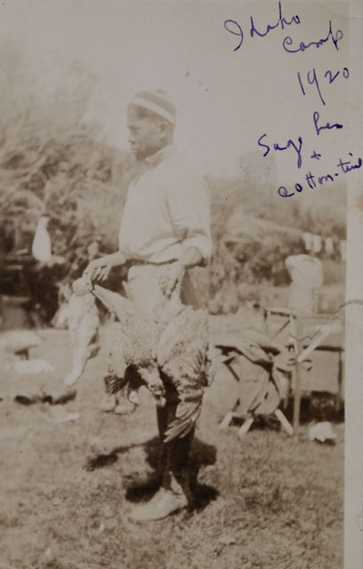
http://collections.theautry.org/mwebcgi/mweb.exe?request=record;id=M596600;type=102
Object: Photograph
Maker: Unknown
Date: 1920
Object ID: 2004.22.27.31
Notes: Photograph of an unidentified man, 1920. Inscribed: “Idaho Camp 1920/Sage Hen + Cotton Time.”

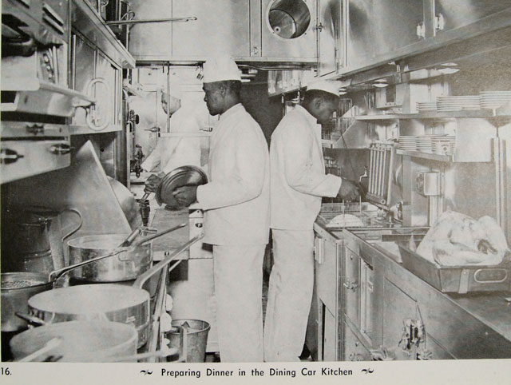
http://collections.theautry.org/mwebcgi/mweb.exe?request=record;id=M600246;type=102
Object: Photograph
Maker: Unknown
Title: Preparing Dinner in the Dining Car Kitchen
Date: 1920-1968
Object ID: 90.253.1940.13
Notes: Reproduction of photograph featuring a group of Black men cooking in a railroad dining car.
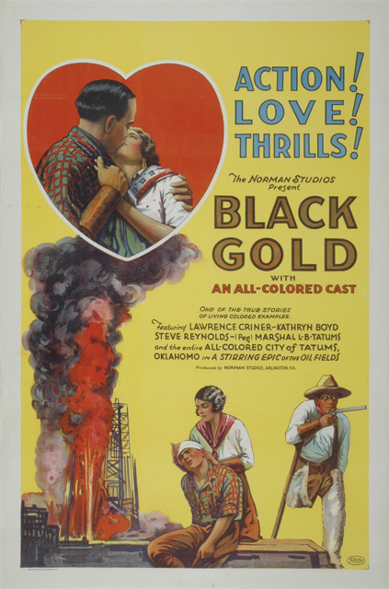http://collections.theautry.org/mwebcgi/mweb.exe?request=record;id=M519169;type=102
Object: Poster
Maker: Ritchey Lithograph Corporation
Date: 1927
Object ID: 93.175.2
Notes: Movie poster for Norman Film Manufacturing Company's Black Gold (1927).
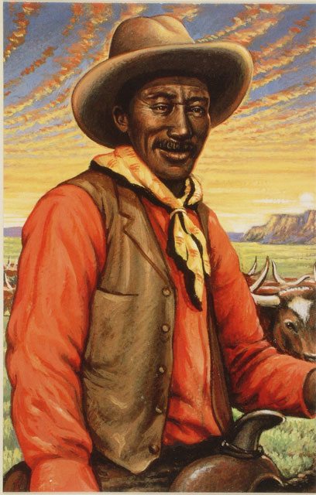
http://collections.theautry.org/mwebcgi/mweb.exe?request=record;id=M520878;type=102 \
Object: Postcard
Maker: United States Postal Service
Date: 1993
Object ID: 95.204.1.5
Notes: Postcard of Bill Pickett from the Legends of the West series, 1993.

