Mexico’s boundaries and names have changed throughout time. The Aztecs first used the word “Mexico” in their nahuatl language when they established their empire in the 13th century. Spanish colonizers called their conquered territory “New Spain” and controlled the area between 1519 and 1821. To protect their territories in California, Spain sent members of the Catholic church to set up a system of missions, capitalizing on the slave labor of Native California communities. After winning sovereignty in 1821, Mexican officials secularize the missions, granting them as ranchos to Mexican individuals.

*Some of the image links have restricted access to Autry staff; if you would like access, please email mselway@theautry.org.

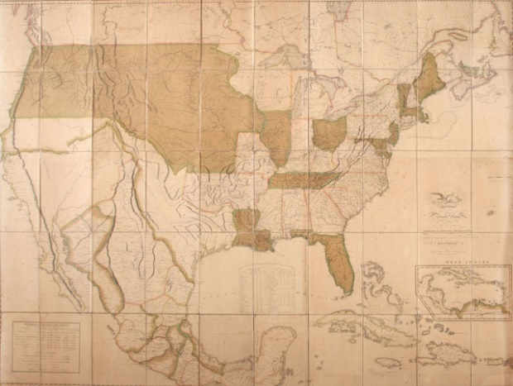
http://collections.theautry.org/mwebcgi/mweb.exe?request=record;id=M542287;type=103
Object: Map
Maker: John Melish, J. Vallance, and H.S. Tanner
Title: Map of the United States of America with the Contiguous British and Spanish Possessions
Date: 1820
Object ID: 90.253.282
Notes: John Melish drew the first coast-to-coast map made in America to show the competing territorial claims of different nations. The map also included information from Lewis and Clark’s travels.

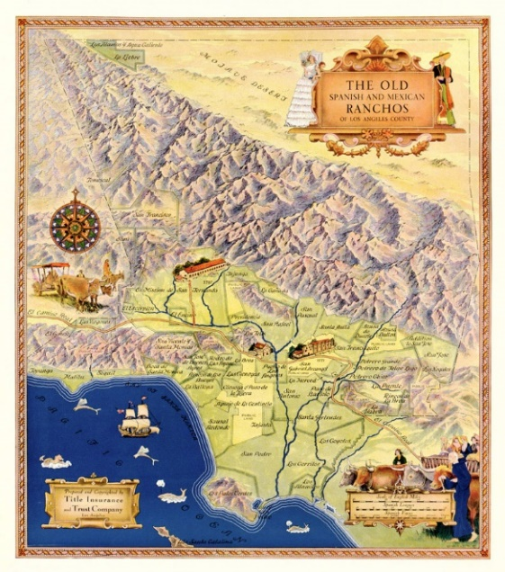
http://collections.theautry.org/mwebcgi/mweb.exe?request=record;id=M620269;type=103
Object: Map
Title: The Old Spanish and Mexican Ranchos of Los Angeles County
Date: 1930–1937
Object ID: TSW-57
Notes: "The Old Spanish and Mexican Ranchos of Los Angeles County/ Prepared and copyrighted by Title Insurance Company/ Los Angeles. Hi Res: https://www.loc.gov/resource/g4363l.ct001439/?r=-0.354,-0.042,1.561,1.248,0
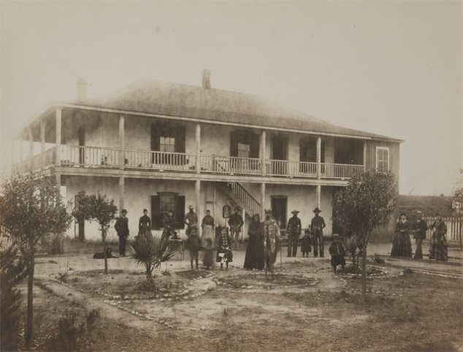
http://collections.theautry.org/mwebcgi/mweb.exe?request=record;id=M39196;type=102
Object: Photograph
Maker: C.J. Crandall
Title: The Family and Adobe of Antonio Maria Lugo
Date: Early to mid-1900s
Object ID: P.17432
Note: The Spanish Army granted Antonio Maria Lugo 29,514 acres of land in the Spanish colony of Alta California which he named Rancho San Antonio. This photograph is of his descendants in front of a two-story adobe, a home typically built on Spanish ranchos.

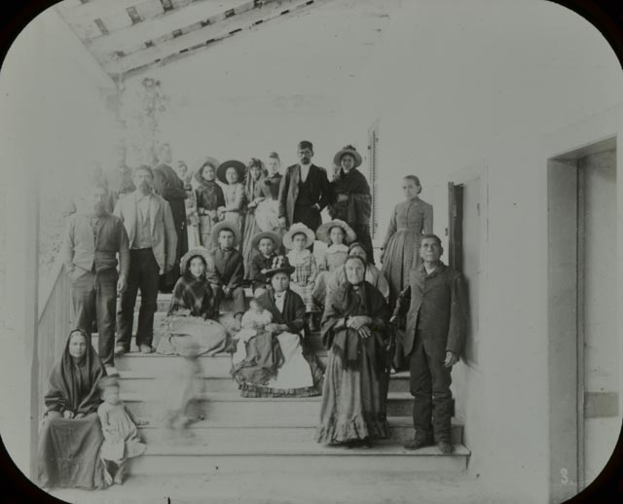
http://collections.theautry.org/mwebcgi/mweb.exe?request=record;id=M296259;type=102
Object: Lantern slide
Title: The Del Valle Family at Rancho Camulos
Object ID: LS.6355
Note: The Mexican government granted Antonio del Valle the 48,612-acre Rancho San Francisco near San Fernando, California in 1839. This photograph is of his descendants.

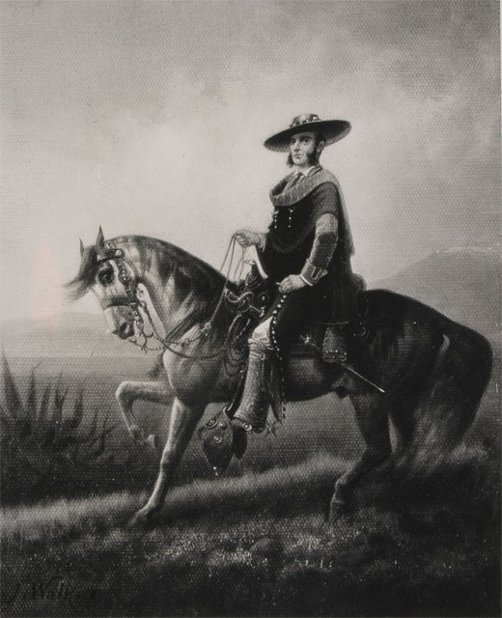
http://collections.theautry.org/mwebcgi/mweb.exe?request=record;id=M33959;type=102
Object: Photograph
Maker: J. Walker and John Dewar
Title: Painting Portrait of Californio Land Owner
Object ID: P.41749A
Notes: A Californio was a Spanish-speaking wealthy landowner (of ranchos) who lived in California during Spanish rule (1750–1832) and Mexican rule (1832–1850).

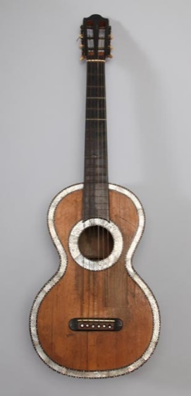
http://collections.theautry.org/mwebcgi/mweb.exe?request=record;id=M73254;type=101
Object: Guitar
Date: Circa 1850
Object ID: 153.L.13
Notes: The 1849 California Gold Rush caused the demand for beef to increase, making many Mexican Californian, or Californio, rancheros wealthy. Rancher Miguel de la Guerra gave this fancy guitar to his fiancée, Trinidad Ortega y Pico, the niece of the last Mexican governor in California, Pío Pico.

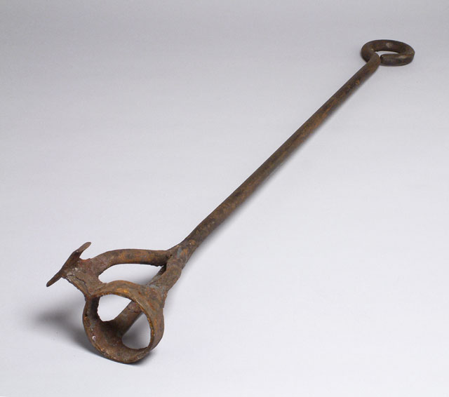
http://collections.theautry.org/mwebcgi/mweb.exe?request=record;id=M552762;type=101
Object: Branding iron
Date: 1840s–1850s
Object ID: 89.136.280
Note: Branding iron for the TO brand from Santa Marguerita Rancho, near Oceanside, California. Santa Marguerita Rancho was the largest Spanish land grant in California with 130,000 acres of ranchland and was granted to Pío Pico and his brother Andrés in 1841. Branding irons burned a symbol onto cattle and horse hides to show ownership.

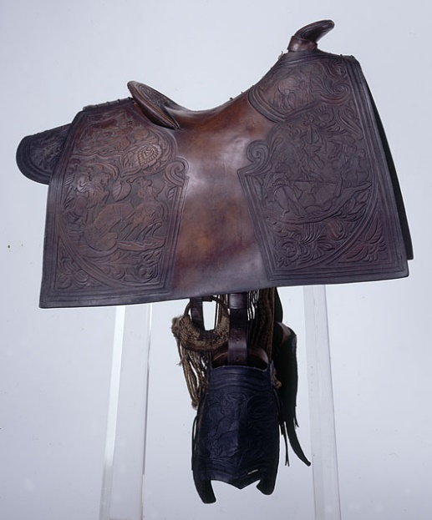
http://collections.theautry.org/mwebcgi/mweb.exe?request=record;id=M567247;type=101
Object: Saddle
Date: Circa 1855
Object ID: 99.6.1
Note: Saddles were used to ride horses throughout ranchos and round up cattle. This saddle has a flat Mexican-style horn (handle) and cantle (curved back of seat), with hand-carved stirrups made from one piece of maple wood.

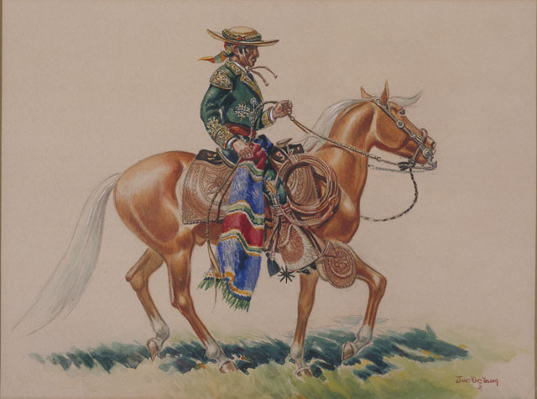
http://collections.theautry.org/mwebcgi/mweb.exe?request=record;id=M562497;type=101
Object: Painting
Maker: Joe De Yong
Title: A California Cabellero–1820
Date: June 10, 1937
Object ID: 93.47.2
Note: This is a depiction of a cabellero, a skilled horseman. The rancho life was often romanticized (making something seem better than it is) in art and literature.

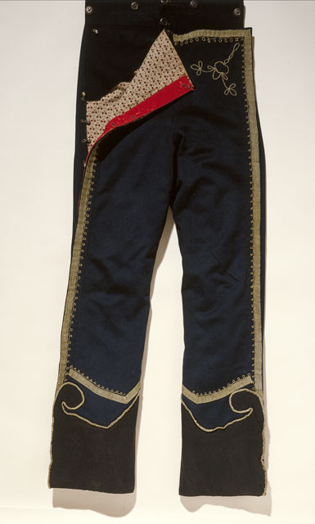
Object: Pants
Date: 1834–1850
Object ID: 93.21.11
Notes: These pants were said to be owned and worn by Don Fernando Sepulveda, a member of the Sepulveda family who owned and ran ranchos under Spanish and Mexican rule in California.

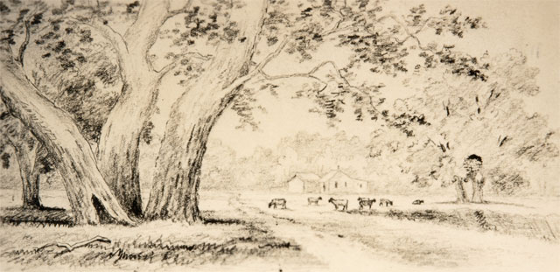
http://collections.theautry.org/mwebcgi/mweb.exe?request=record;id=M128636;type=102
Object: Photograph
Maker: Hazel Harvey and Henry Chapman Ford
Title: Southern California Ranch Scene, Circa 1880
Date: November 20, 1936
Object ID: P.39831
Notes: This is a photograph of an etching created as part of a federal art project.

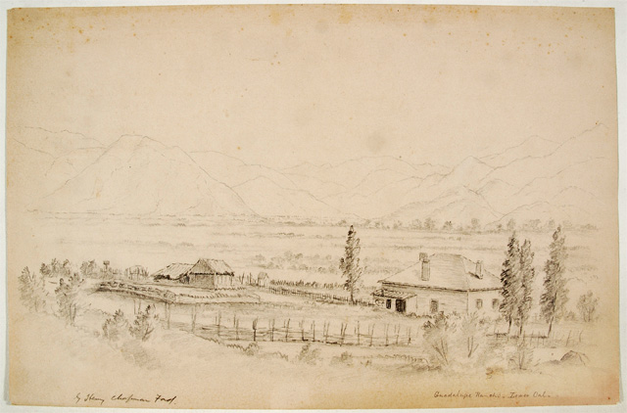
http://collections.theautry.org/mwebcgi/mweb.exe?request=record;id=M225720;type=101
Object: Drawing
Maker: Henry Chapman Ford
Title: Guadalupe Rancho, Lower California
Object ID: 14.C.944

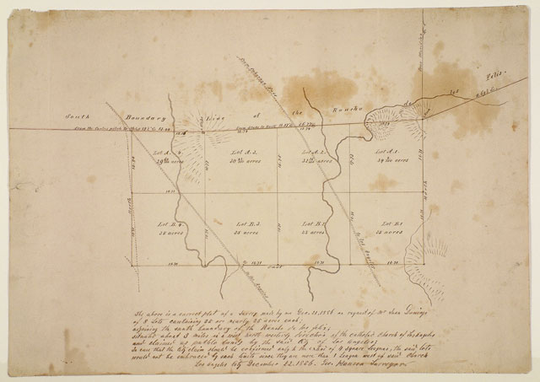
http://collections.theautry.org/mwebcgi/mweb.exe?request=record;id=M549779;type=103
Object: Map
Maker: George Mansen
Title: Southern Boundary of Rancho de Los Feliz
Date: December 22, 1856
Object ID: 98.91.2
Note: When the United States won the Mexican American War in 1848, Mexican ranchos had to prove ownership to the U.S. government to keep the land. Rancheros (rancho owners) had to petition to the U.S. government and submit a map survey of the land and documentation of ownership.

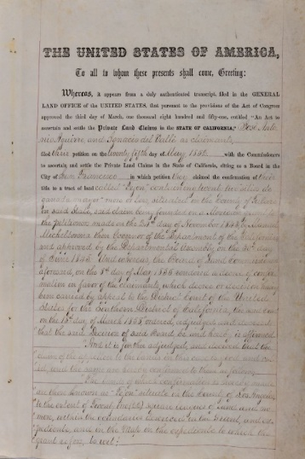
http://collections.theautry.org/mwebcgi/mweb.exe?request=record;id=M667850;type=105
Object: Document
Title: Tejon Ranch Deed, Jose Antonio Aguirre and Ignacio del Valle, May 1863
Date: 1863
Object ID: 2018.34.1
Note: This is a document in which the United States government officially recognized the former Mexican Rancho owned by Jose Antonio Aguirre and Ignacio del Valle.

