The 1845 annexation of Texas led to the Mexican-American War and the 1848 Treaty of Guadalupe Hidalgo, forcing Mexico to lose almost one-half of its land—an area larger than the Louisiana Purchase. Mexicans living in what was now the United States were given a choice of continuing to live on their land and be granted full rights as citizens of the United States or move to what was now Mexico. However, those who decided to stay and become U.S. citizens eventually found that their rights and equality were almost immediately called into question and land titles held by former Mexicans were taken away. Their descendants have been fighting for their rights ever since.

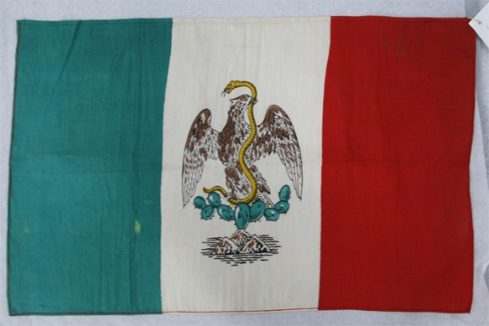
http://collections.theautry.org/mwebcgi/mweb.exe?request=record;id=M103796;type=101
Object Name: Mexican flag
Date: 1920
Object ID: 79.L.34
Note: Mexico ruled California from 1832 to 1849.

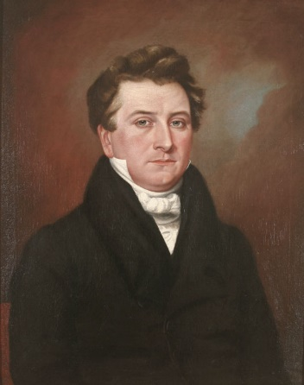
http://collections.theautry.org/mwebcgi/mweb.exe?request=record;id=M548922;type=101
Object Name: Painting
Maker: Unknown artist
Title: Portrait of Thomas P. Larkin
Date: 1832–1840s
Object ID: 88.238.1
Notes: Larkin first settled as a merchant in Monterey, California, in 1832. He served as United States consul in Mexican California. In October of 1845, Larkin was appointed as a "confidential agent" and instructed to work toward the secession of California from Mexico and its becoming part of the United States.

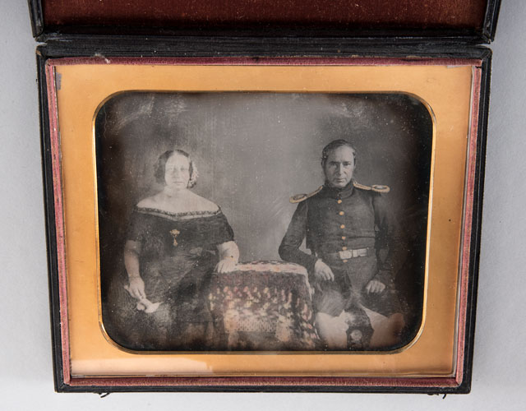
http://collections.theautry.org/mwebcgi/mweb.exe?request=record;id=M541222;type=102
Object Name: Photograph
Maker: Unknown artist
Date: Circa 1845
Object ID: 92.140.1
Notes: Commodore John D. Sloat and wife, Abbey Gordon. Commodore Sloat landed in Monterey, July 7, 1846, and asked California residents to reject Mexican rule and accept United States rule. The ‘Republic of California’ established by the Bear Flag Revolt ended with U.S. occupation of San Francisco and Sonoma.

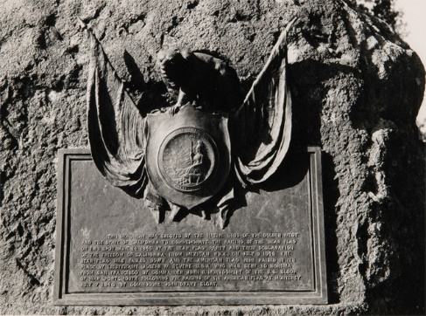
http://collections.theautry.org/mwebcgi/mweb.exe?request=record;id=M20021;type=102
Object Name: Photograph
Maker: Frank A. Schilling
Title: Monument Commemorating the California Bear Flag Revolt
Date: 1946
Object ID: P.13370
Notes: Photograph taken in Sonoma, California, of the monument commemorating the California Bear Flag Revolt.

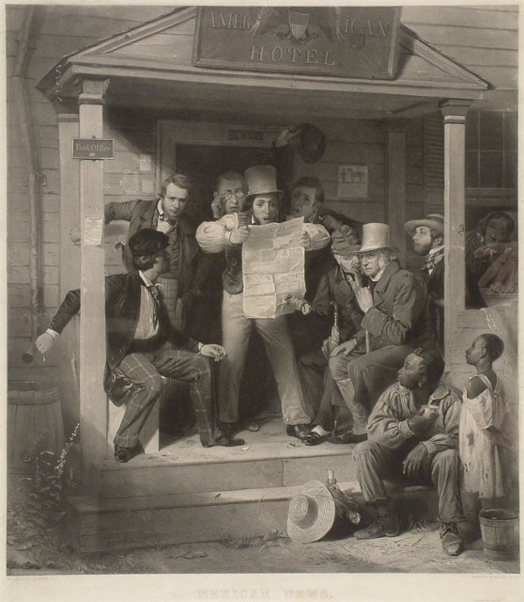
http://collections.theautry.org/mwebcgi/mweb.exe?request=record;id=M555282;type=101
Object Name: Print
Maker: Unknown artist
Title: War News from Mexico
Date: 1846–1848
Object ID: 88.162.2
Notes: This print was one of fourteen thousand made from a popular painting by Richard Woodville. The artist shows various people reacting to the news about a war with Mexico.

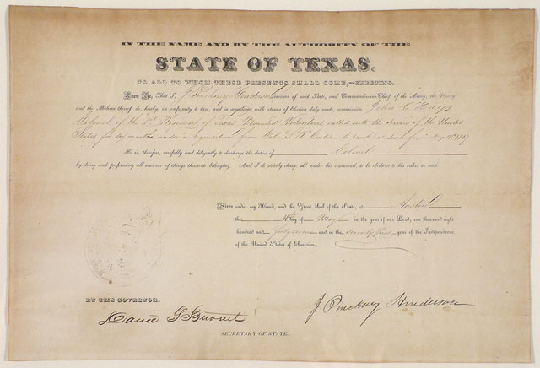
http://collections.theautry.org/mwebcgi/mweb.exe?request=record;id=M533661;type=105
Object Name: Document
Object ID: 90.132.5
Title: Commission of John C. Hays of the 1st Regiment of Texas Mounted Volunteers
Date: 1847
Document certifying commission of John C. Hays as a Colonel in 1st Regiment of Texas Mounted Volunteers, Austin, Texas, May 11, 1847. The First Regiment of Texas Mounted Rifle Volunteers, unofficially known as Hay's Texas Rangers, was a United States Volunteer regiment raised in June 1846, with a core of Texas Rangers, for service in the Mexican–American War.

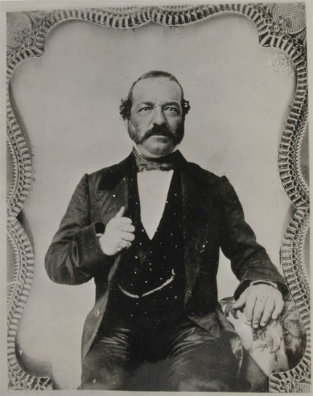
http://collections.theautry.org/mwebcgi/mweb.exe?request=record;id=M114118;type=102
Object Name: Photograph
Maker: Unidentified photographer
Title: A Portrait of Andrés Pico
Date: Mid-1800s, printed 1900s
Object ID: P.36760
Notes: Andrés Pico was a Californio and Mexican General during the Mexican-American War who commanded the Mexican forces in California, the California Lancers.

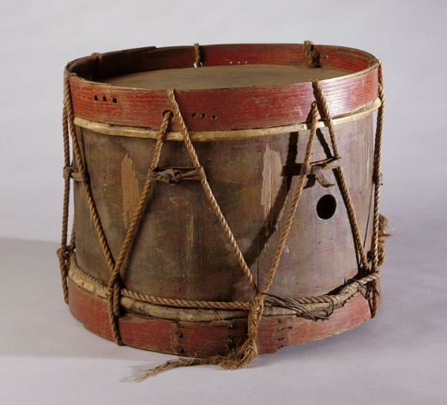http://collections.theautry.org/mwebcgi/mweb.exe?request=record;id=M512050;type=101
Object Name: Drum
Date: 1846
Object ID: 93.21.8
Notes: This drum might have been used by the army of General Andrés Pico.

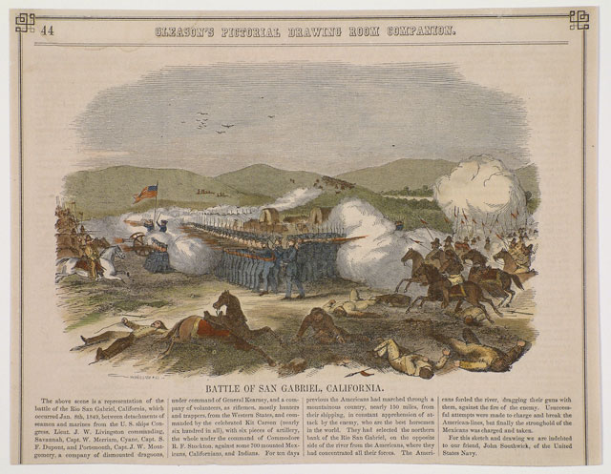http://collections.theautry.org/mwebcgi/mweb.exe?request=record;id=M507054;type=105
Object Name: Newspaper
Title: Gleason's Pictorial Drawing Room Companion
Date: 1849
Object ID: 90.138.83
Notes: Newspaper page featuring a drawing depicting the Battle of San Gabriel, California, on January 8, 1849.
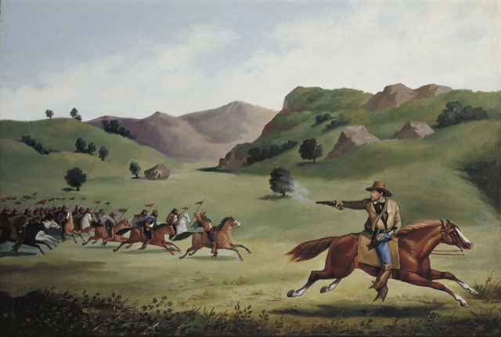
http://collections.theautry.org/mwebcgi/mweb.exe?request=record;id=M514879;type=101
Object Name: Painting
Maker: Alexander Edouart
Title: The Chase
Date: 1857
Object ID: 92.33.1
Notes: This painting, commissioned in 1857, depicts Henry L. Ford, a captain in General John Frémont's California Battalion, being chased by Californio Lancers during the Mexican-American War in California.

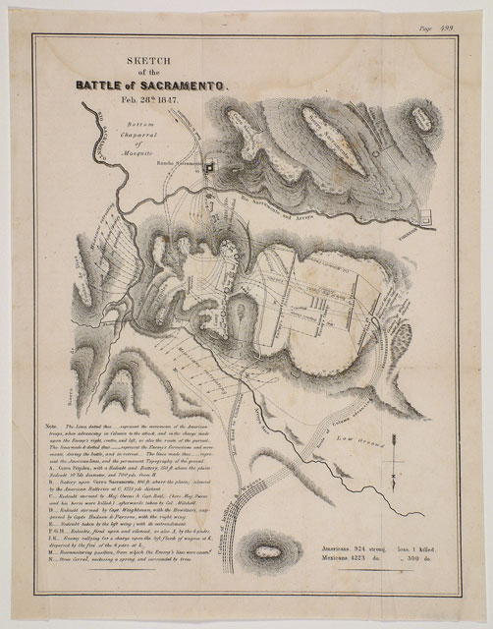http://collections.theautry.org/mwebcgi/mweb.exe?request=record;id=M512559;type=103
Object Name: Map
Title: Sketch of the Battle of Sacramento, Feb. 28th, 1847
Date: Circa 1847
Object ID: 90.138.94
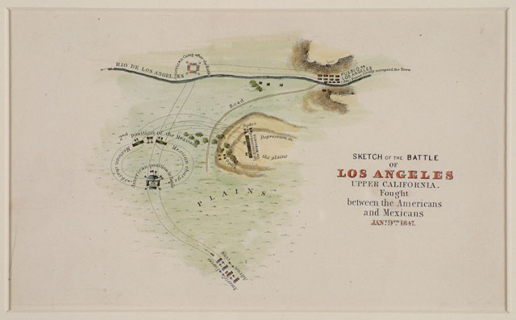http://collections.theautry.org/mwebcgi/mweb.exe?request=record;id=M558896;type=101
Object Name: Print
Maker: United States government
Title: Sketch of the Battle of Los Angeles Upper California, 1847
Date: 1847
Object ID: 90.138.131

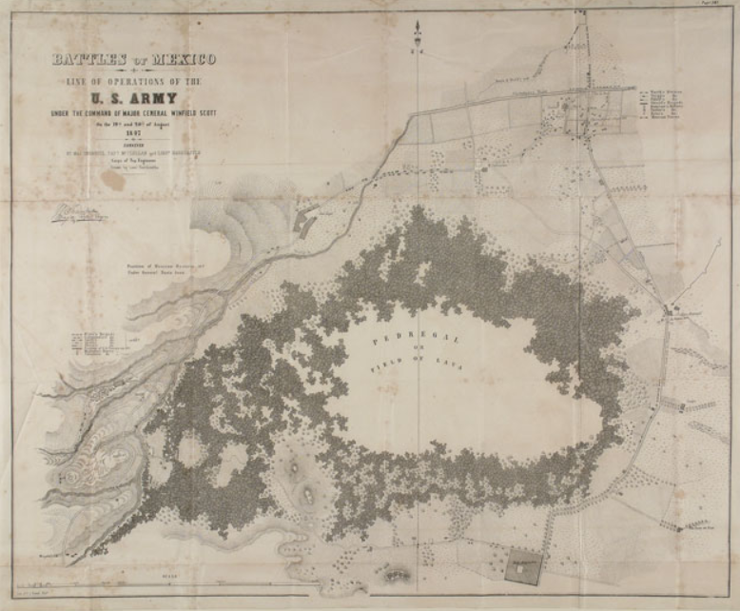http://collections.theautry.org/mwebcgi/mweb.exe?request=record;id=M522184;type=103
Object Name: Map
Maker: Edmund Hardcastle
Title: Battles of Mexico/Line of Operations of the /U.S. Army/Under the command of Major General Winfield Scott
Date: 1847
Object ID: 90.138.90
Notes: Map of United States Army positions near the Churubusco River, Mexico.
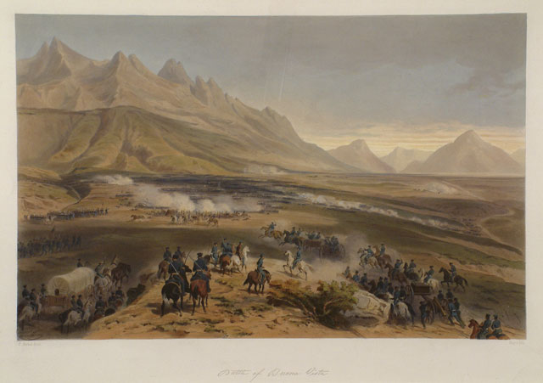http://collections.theautry.org/mwebcgi/mweb.exe?request=record;id=M560571;type=101
Object Name: Print
Maker: Carl Nebel
Title: Battle of Buena Vista
Date: 1851
Object ID: 90.253.291.4
Notes: This battle took place near Monterey, Mexico.

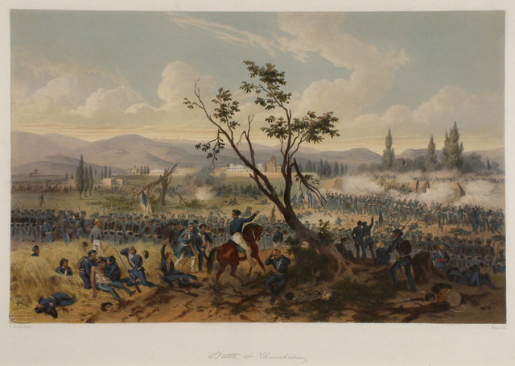http://collections.theautry.org/mwebcgi/mweb.exe?request=record;id=M512551;type=101
Object Name: Print
Maker: Carl Nebel
Title: Battle at Churubusco
Date: 1851
Object ID: 90.253.291.8
Notes: The Battle of Churubusco was fought near Mexico City on August 20, 1847. General Winfield Scott led the U.S. forces and General Antonio Lopez de Santa Anna led the Mexican forces. Soon after, the U.S. captured Mexico City.

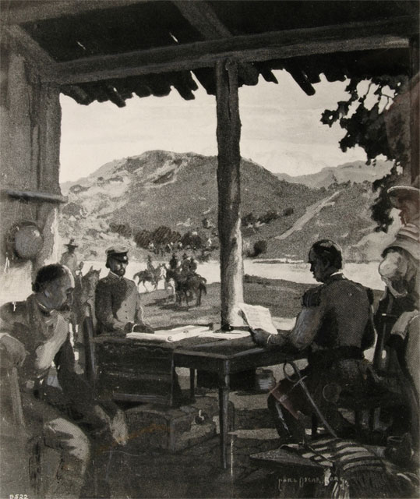
http://collections.theautry.org/mwebcgi/mweb.exe?request=record;id=M27098;type=102
Object Name: Photograph
Maker: Charles Chester Pierce and Carl Oscar Borg
Title: The Signing of the Treaty of Cahuenga
Object ID: P.14679
Notes: Photograph of a painting of the signing of the Treaty of Cahuenga in Los Angeles, California, 1847, which resulted in a ceasefire between Mexicans and Americans in California.

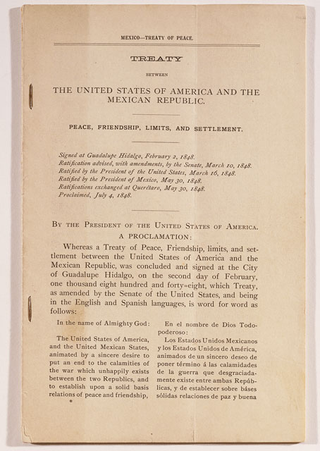http://collections.theautry.org/mwebcgi/mweb.exe?request=record;id=M537908;type=105
Object Name: Document
Title: Treaty between the United States of American and the Mexican Republic
Date: Circa 1848
Object ID: 90.253.301
Notes: Signed at Guadalupe Hidalgo, February 2, 1848, the Treaty marked the end of the war. In return for fifteen million dollars, Mexico ceded to the United States the territory of present-day California, Nevada, Utah, and parts of Arizona, New Mexico, Oklahoma, Colorado, and Wyoming.
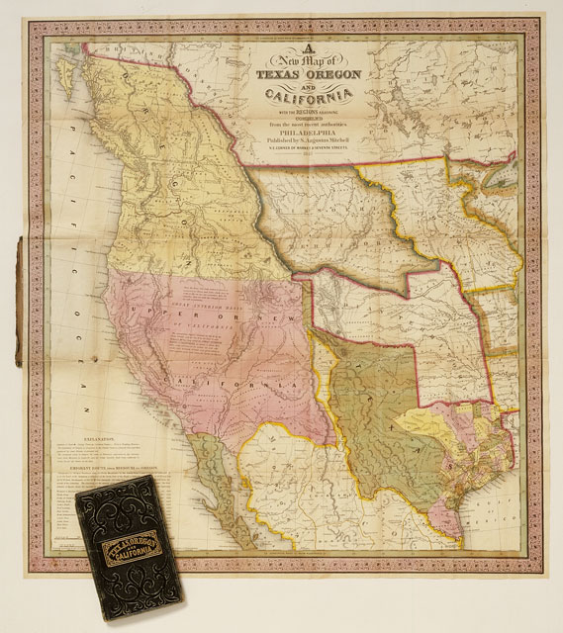
http://collections.theautry.org/mwebcgi/mweb.exe?request=record;id=M564724;type=103

Object Name: Map
Maker: Samuel Augustus Mitchell
Title: A New Map of Texas, Oregon, and California: With the Regions Adjoining
Date: 1846
Object ID: 90.253.289
Notes: The map includes the states of California, Texas, Oregon, Washington state, Missouri, and Indian Territory. Includes a table of distances along the Emigrant Route from Missouri to Oregon.

