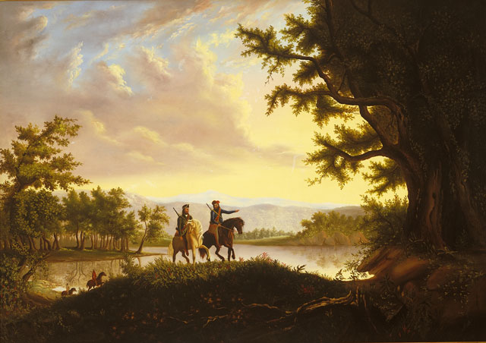
http://collections.theautry.org/mwebcgi/mweb.exe?request=record;id=M555606;type=101
Object: painting
Maker: Thomas Mickell Burnham
Title: The Lewis and Clark Expedition
Date: circa 1850
Object ID: 92.11.1
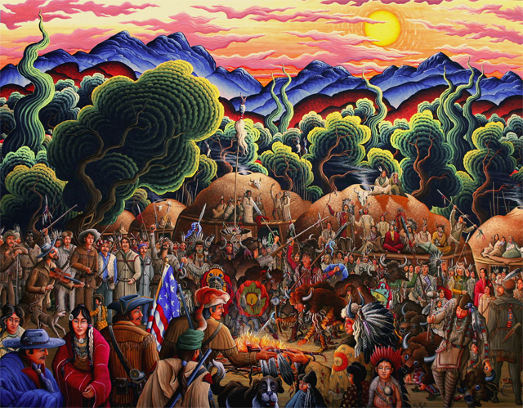
http://collections.theautry.org/mwebcgi/mweb.exe?request=record;id=M600463;type=101
Object: painting
Maker: Kim Wiggins
Title: Lewis & Clark Among the Mandan
Date: 2004
Object ID: 2005.24.1

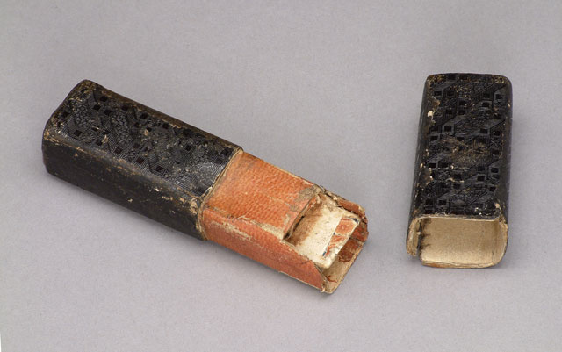
http://collections.theautry.org/mwebcgi/mweb.exe?request=record;id=M567386;type=101
Object: microscope
Maker: N/A
Date: ca. 1800
Object ID: 98.128.1
Notes: European entomologist's (a person who studies insects) field microscope with doublet-type glass lens and adjustable fittings.
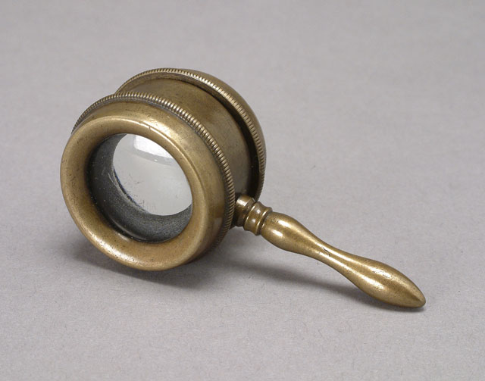
http://collections.theautry.org/mwebcgi/mweb.exe?request=record;id=M520659;type=101
Object: glass, magnifying
Maker: N/A
Date: 1829-1850
Object ID: 87.124.2
Notes: Magnifying glass with Coddington-style lens to enable greater magnification. Typical of those used by naturalists on Federal surveys of the West.

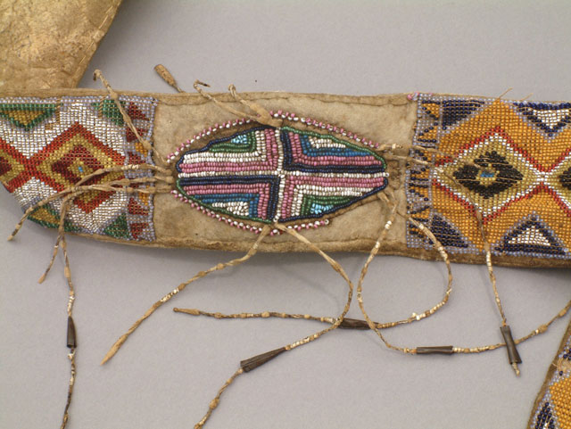
http://collections.theautry.org/mwebcgi/mweb.exe?request=record;id=M533037;type=101
Object: bag, hunting
Culture: Cheyenne
Date: circa 1850
Object ID: 97.138.1
Notes: Hunting bag, made by Cheyenne Indians, circa 1850. Remade from various pieces.
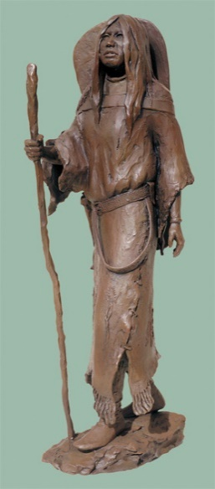
http://collections.theautry.org/mwebcgi/mweb.exe?request=record;id=M579494;type=101
Object: sculpture
Maker: Richard V. Greeves
Title: Bird Woman
Date: 2001
Object ID: 2002.4.1
Notes: Life size bronze sculpture portrays the Shoshone woman known as Sacagawea.

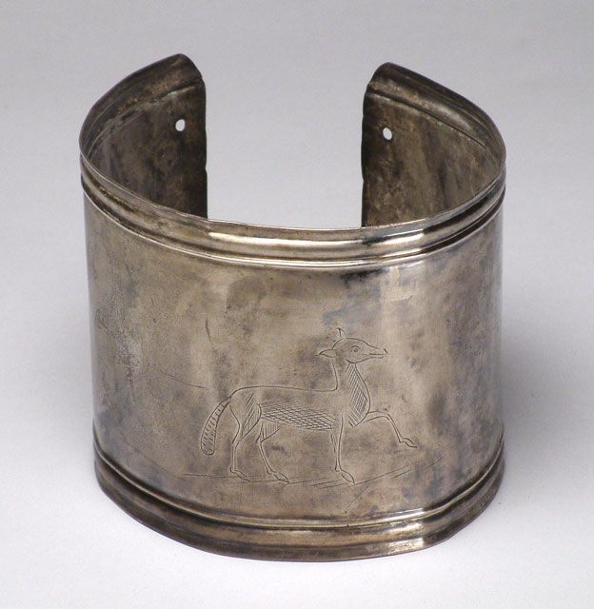
http://collections.theautry.org/mwebcgi/mweb.exe?request=record;id=M533557;type=101
Object: armlet
Maker: Narcisse Roy
Date: 1801-1806
Object ID: 90.63.7
Notes: Silver armlet. One of many trade goods made in Montreal for barter with Indians in the fur trade.
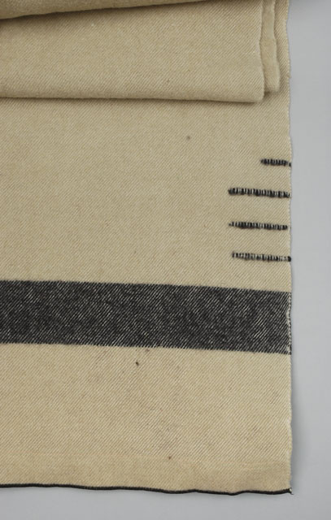
http://collections.theautry.org/mwebcgi/mweb.exe?request=record;id=M576013;type=101
Object: blanket
Maker: Hudson’s Bay Company
Date: circa 1880
Object ID: 2001.19.3
Notes: Beige and black striped wool blanket, designed and manufactured by Hudson's Bay Company, circa 1880. Twice the size of one that would normally be sold or traded.
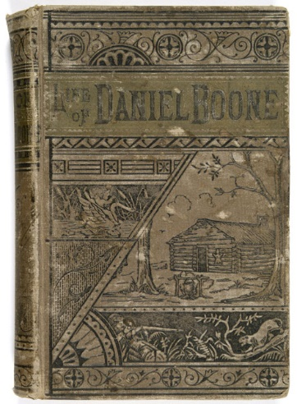
http://collections.theautry.org/mwebcgi/mweb.exe?request=record;id=CGAV03-B436;type=106
Object: Book
Title: Life of Daniel Boone, the great western hunter and pioneer comprising an account of his early history, his daring and remarkable career as the first settler of Kentucky, his thrilling adventures with the Indians, and his wonderful skill, coolness and sagacity under all the hazardous and trying circumstances of western border life / by Cecil B. Hartley ; To which is added his autobiography complete as dictated by himself and showing his own belief that he was an instrument ordained to settle the wilderness.
Maker: Hartley, Cecil B.
Date: [©1865?]
Call Number: ROSENSTOCK 90.253.761

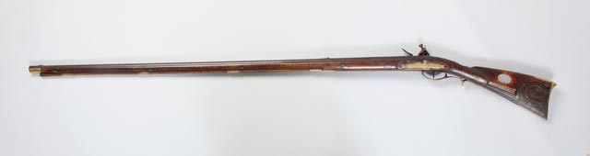
http://collections.theautry.org/mwebcgi/mweb.exe?request=record;id=M642709;type=101
Object Name: rifle
Title: Kentucky Rifle
Date: circa 1807
Object ID: 2012.2.35

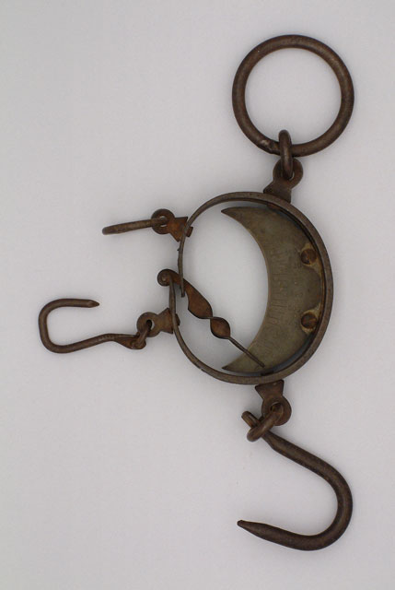
http://collections.theautry.org/mwebcgi/mweb.exe?request=record;id=M561089;type=101
Object: scale
Maker: Henry Boker
Date: mid-19th century
Object ID: 85.1.1489
Notes: Hanging scale, made by Henry Boker, mid-1800s. Used for weighing hides and furs.

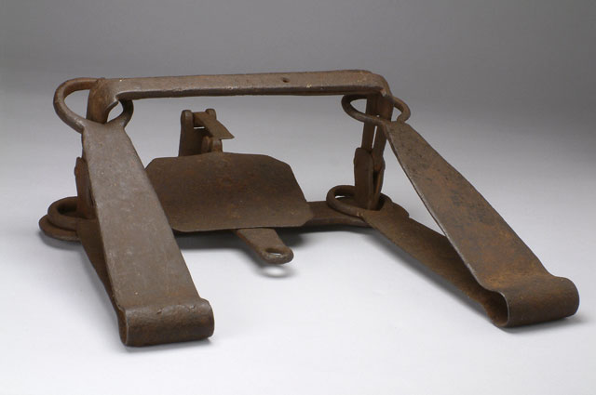
http://collections.theautry.org/mwebcgi/mweb.exe?request=record;id=M520770;type=101
Object Name: trap, beaver
Date: 1800-1840s
Object ID: 90.96.

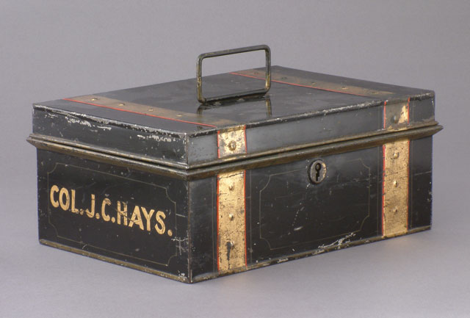
http://collections.theautry.org/mwebcgi/mweb.exe?request=record;id=M552623;type=101
Object: box, document
Maker: N/A
Date: 1800s
Object ID: 90.107.2
Notes: Painted iron document box with attached lid; gold-colored painted letters on side: COL.J.C.HAYS.
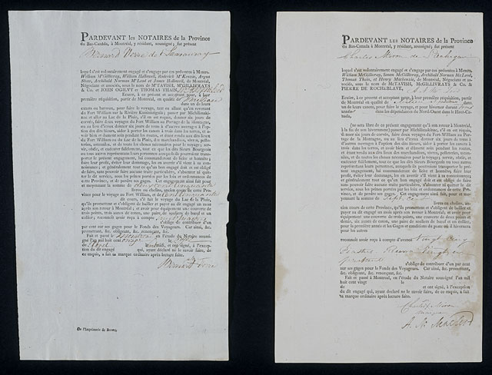
http://collections.theautry.org/mwebcgi/mweb.exe?request=record;id=M576248;type=105
Object Name: contract
Maker: North West Company
Title: Voyageur Contract
Date: 1811
Object ID: 2001.23.1
Notes: Canadian fur trade company summer contract for an ordinary, unskilled voyageur to make the trip from Montreal to Fort William.
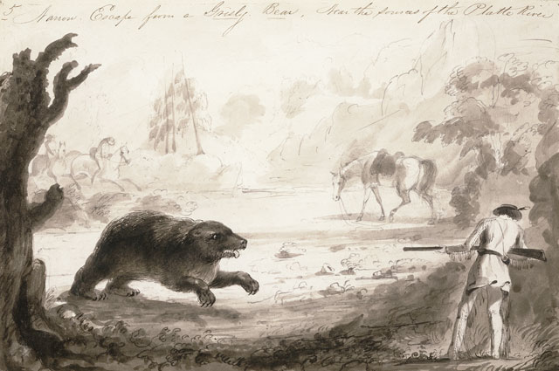
http://collections.theautry.org/mwebcgi/mweb.exe?request=record;id=M545161;type=101
Object Name: drawing
Maker: Alfred Jacob Miller
Title: Narrow Escape From a Grisly Bear
Date: 1837
Object ID: 92.235.1
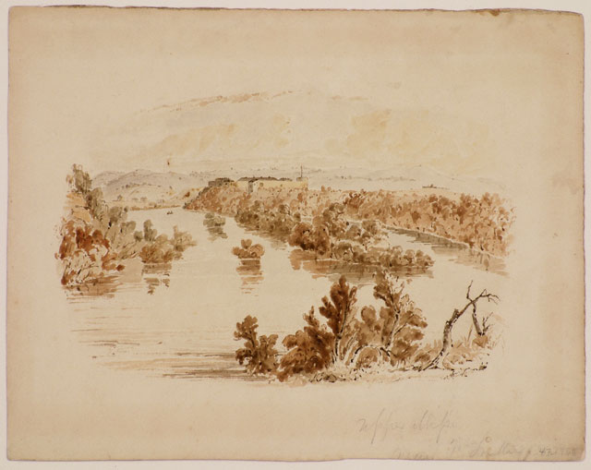
http://collections.theautry.org/mwebcgi/mweb.exe?request=record;id=M513619;type=101
Object: drawing
Maker: Seth Eastman
Title: Upper Mississippi, near Ft. Snelling
Date: circa 1841-1848
Object ID: 88.108.68
Notes: Drawing by Seth Eastman, UPPER MISSISSIPPI, NEAR FT. SNELLING.

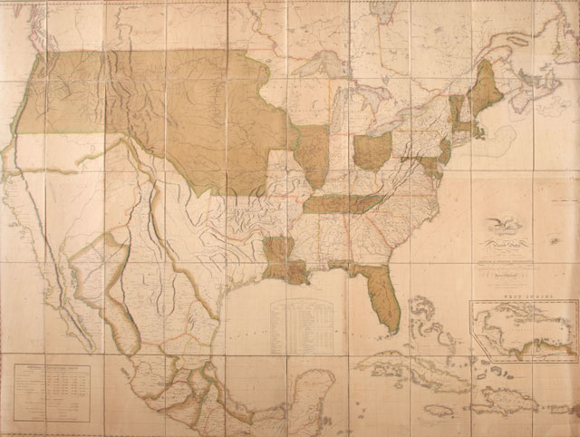
http://collections.theautry.org/mwebcgi/mweb.exe?request=record;id=M542287;type=103
Object: map
Maker: John Melish; J. Vallance & H.S. Tanner
Title: Map of the United States of America with the Contiguous British and Spanish Possessions
Date: 1820
Object ID: 90.253.282
Notes: The map included information from Lewis and Clark’s travels. This map shows the West in the year Congress passed the Missouri Compromise.
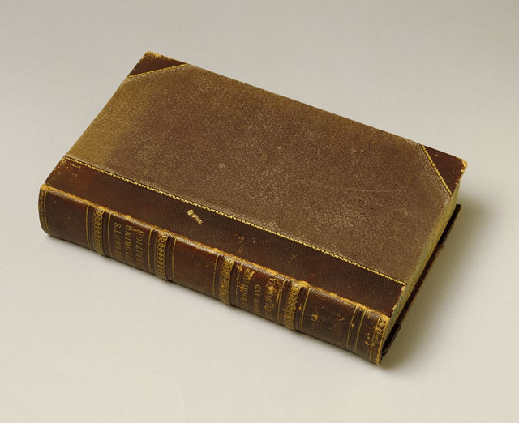
http://collections.theautry.org/mwebcgi/mweb.exe?request=record;id=ocm00563061%20;type=106
Object: book
Maker: John Charles Fremont
Title: Report of the exploring expedition to the Rocky mountains in the year 1842, and to Oregon and north California in the years 1843-’44 by Brevet Captain J.C. Fremont, of the topographical engineers, under the orders of Col. J.J. Abert, chief of the Topographical bureau. Printed by order of the Senate of the United States.
Imprint: 1845
Object ID: Fremont, John Charles, 1813-1890
Call Number: 978 F73r, 1845 (SPECIAL COLLECTIONS); ROSENSTOCK 90.253.288; ROSENSTOCK 90.253.312; ROSENSTOCK 90.253.35

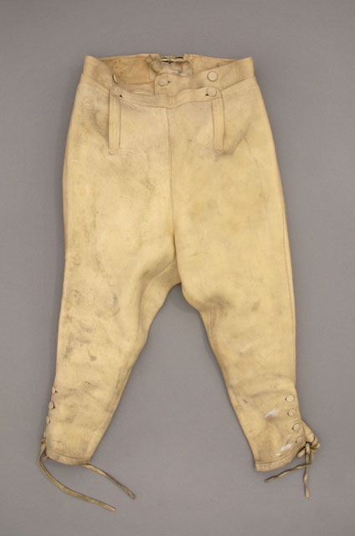
http://collections.theautry.org/mwebcgi/mweb.exe?request=record;id=M563124;type=101
Object: breeches, riding
Maker: unknown artist
Date: 1795-1810
Object ID: 91.58.6
Notes: Man's tan leather breeches, circa early 19th century. Fall front with button closure; adjustable waist with tie strings at back waistline; button and tie closure below knee.
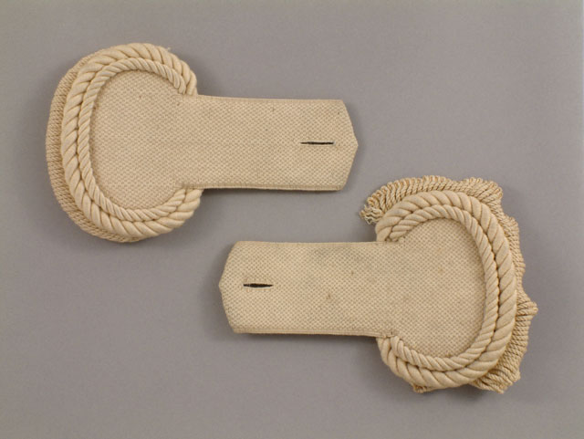
http://collections.theautry.org/mwebcgi/mweb.exe?request=record;id=M508940;type=101
Object: epaulet (pair)
Maker: unknown artist
Date: 1830s
Object ID: 88.167.6
Notes: Off-white wool, cotton and metal 1832 pattern United States Infantry epaulets, a decorative shoulder piece usually on military uniforms.

