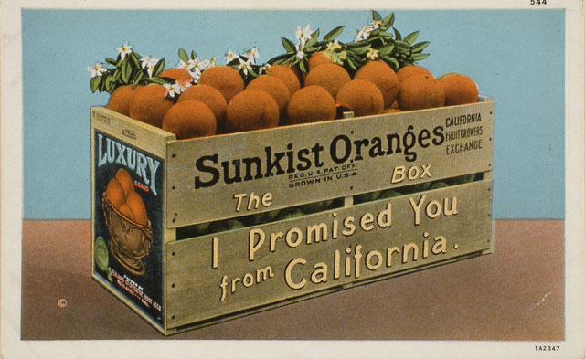http://collections.theautry.org/mwebcgi/mweb.exe?request=record;id=M539521;type=102
Object Name: Postcard
Maker: Western Publishing and Novelty Company
Date: 1907-1929
Object ID: 91.170.721
Notes: Postcard of crate of Sunkist oranges, no. 544, 1907-1929. Verso: unused.
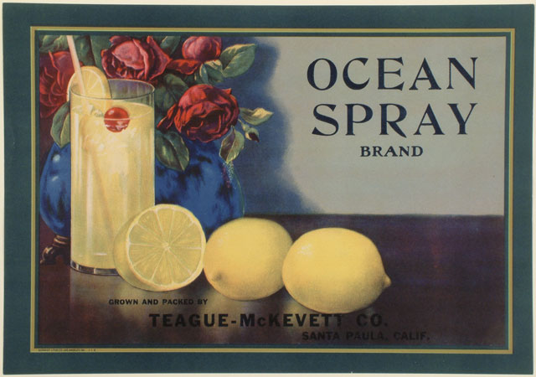http://collections.theautry.org/mwebcgi/mweb.exe?request=record;id=M547424;type=102
Object Name: crate label
Maker: Schmidt Lithograph Company
Title: Ocean Spray
Date: 1920s
Object ID: 91.170.580
Notes: Crate label advertising OCEAN SPRAY brand lemons, Teague-McKevett Company, Santa Paula, California.
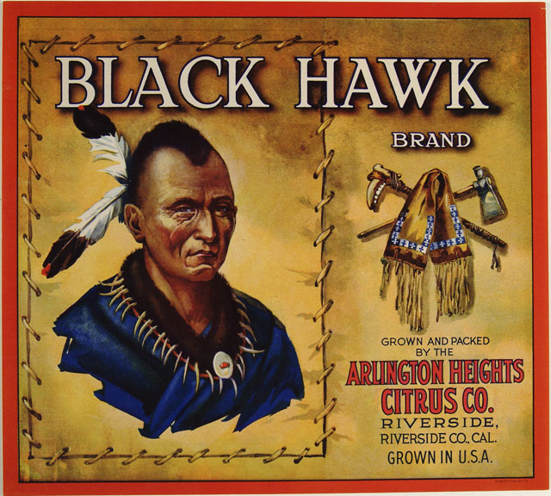
http://collections.theautry.org/mwebcgi/mweb.exe?request=record;id=M505066;type=102
Object Name: crate label
Maker: Schmidt Lithograph Company
Title: Black Hawk
Date: 1920s
Object ID: 91.170.39
Notes: Crate label advertising BLACK HAWK brand oranges, Arlington Heights Citrus Company, Riverside, California.
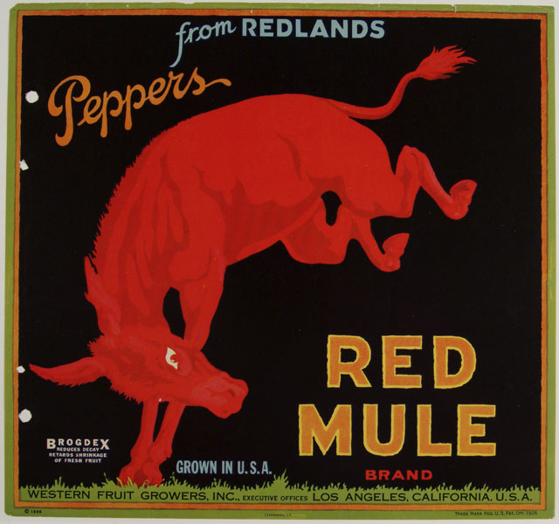
http://collections.theautry.org/mwebcgi/mweb.exe?request=record;id=M539548;type=102
Object Name: crate label
Maker: Lehmann
Title: Red Mule
Date: 1930s
Object ID: 91.170.348
Notes: Crate label advertising RED MULE brand peppers, Western Fruit Growers, Inc., Los Angeles, California.

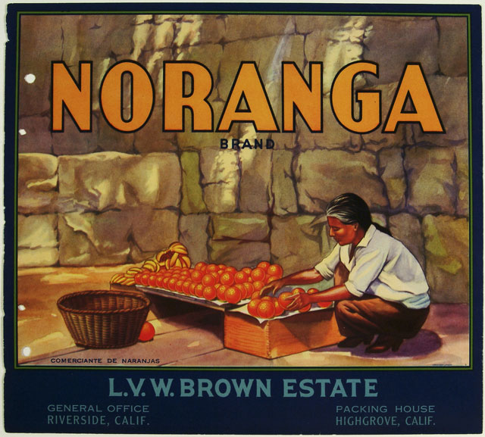http://collections.theautry.org/mwebcgi/mweb.exe?request=record;id=M530835;type=102
Object Name: crate label
Maker: Crocker-Union Lithographers
Title: Noranga
Date: 1930s
Object ID: 91.170.288
Notes: Crate label advertising NORANGA brand oranges, L.V.W. Brown estate, Riverside, California. Southern California had a lot of citrus farms.

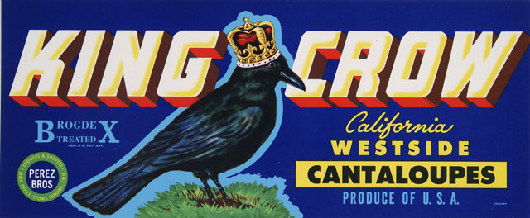http://collections.theautry.org/mwebcgi/mweb.exe?request=record;id=M512588;type=102
Object Name: crate label
Maker: H.S. Crocker Company, Inc.
Title: King Crow
Date: 1930s-1940s
Object ID: 93.202.71
Notes: Crate label advertising KING CROW brand cantaloupes, Perez Brothers, Crows Landing, California.
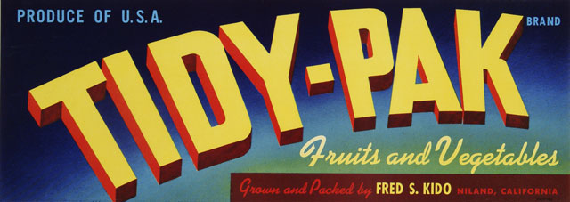http://collections.theautry.org/mwebcgi/mweb.exe?request=record;id=M526769;type=102
Object Name: crate label
Maker: H.S. Crocker Company, Inc.
Title: Tidy-Pak
Date: 1930s-1940s
Object ID: 93.202.79
Notes: Crate label advertising TIDY-PAK brand fruits and vegetables, Fred S. Kido, Niland, California.

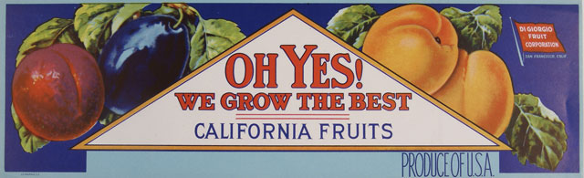http://collections.theautry.org/mwebcgi/mweb.exe?request=record;id=M515076;type=102
Object Name: crate label
Maker: Lehmann
Title: Oh Yes! We Grow the Best
Date: 1930s-1940s
Object ID: 93.202.112
Notes: Crate label advertising OH YES! WE GROW THE BEST brand fruit, DiGiorgio Fruit Company, San Francisco, California.
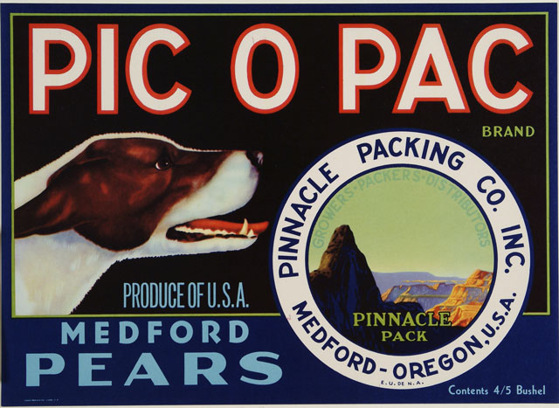http://collections.theautry.org/mwebcgi/mweb.exe?request=record;id=M507188;type=102
Object Name: crate label
Maker: Louis Roesch and Company
Title: Pic o Pac
Date: 1930s-1940s
Object ID: 91.170.684
Notes: Crate label advertising PIC O PAC brand Medford pears, Pinnacle Packing Company, Medford, Oregon.

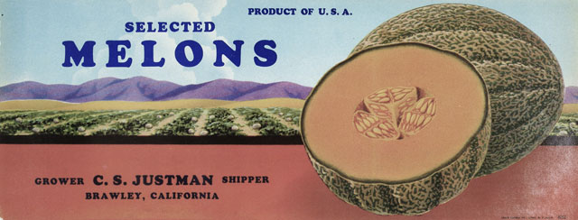http://collections.theautry.org/mwebcgi/mweb.exe?request=record;id=M514307;type=102
Object Name: crate label
Maker: Louis Roesch and Company
Title: Selected
Date: 1930s-1940s
Object ID: 93.202.63
Notes: Crate label advertising SELECTED melons, C.S. Justman, Brawley, California.
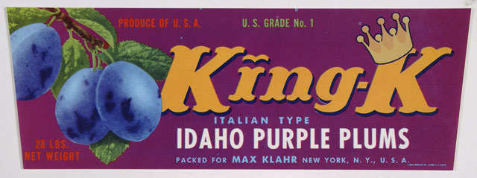http://collections.theautry.org/mwebcgi/mweb.exe?request=record;id=M538913;type=102
Object Name: crate label
Maker: Louis Roesch and Company
Title: King-K
Date: 1930s-1940s
Object ID: 93.202.73
Notes: Crate label advertising KING-K brand plums, Max Klahr, New York, New York.,

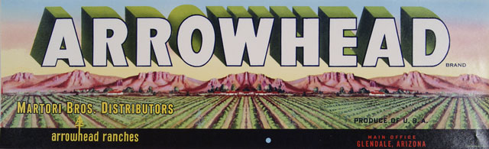http://collections.theautry.org/mwebcgi/mweb.exe?request=record;id=M543811;type=102
Object Name: crate label
Maker: Louis Roesch and Company
Title: Arrowhead
Date: 1930s-1940s
Object ID: 93.202.52
Notes: Crate label advertising ARROWHEAD brand produce, Martori Brothers Distributors, Glendale, Arizona.
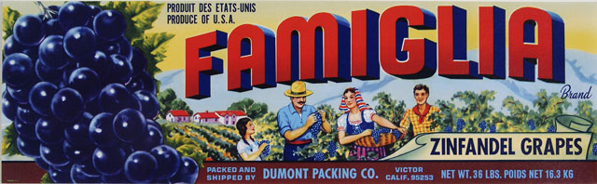http://collections.theautry.org/mwebcgi/mweb.exe?request=record;id=M540417;type=102
Object Name: crate label
Maker: Louis Roesch and Company
Title: Famiglia
Date: 1930s-1940s
Object ID: 93.202.103
Notes: Crate label advertising FMIGLIA brand Zinfandel grapes, Dumont Packing Company, Victor, California.

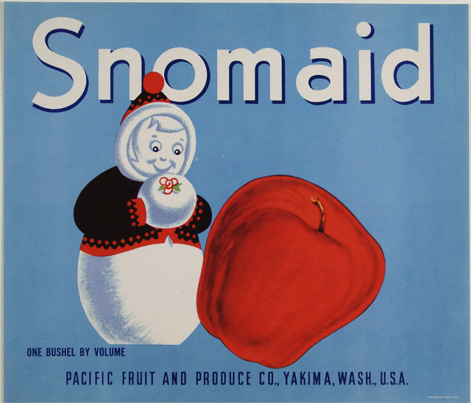http://collections.theautry.org/mwebcgi/mweb.exe?request=record;id=M549338;type=102
Object Name: crate label
Maker: Louis Roesch and Company
Title: Snomaid
Date: 1930s-1940s
Object ID: 91.170.694
Notes: Crate label advertising SNOMAID brand apples, Pacific Fruit and Produce Company, Yakima, Washington.
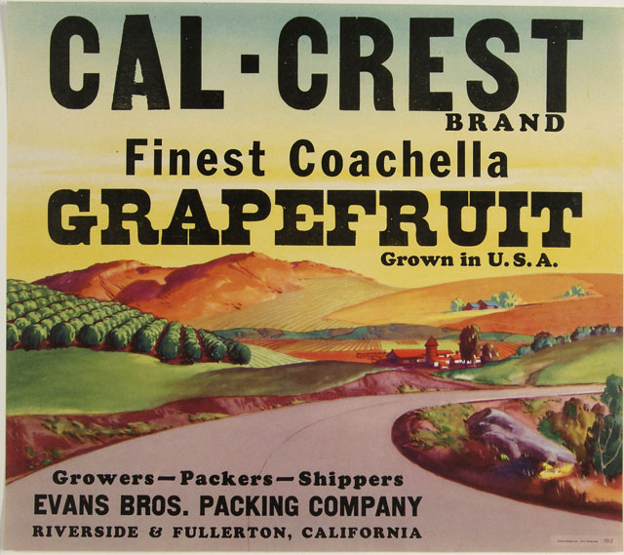http://collections.theautry.org/mwebcgi/mweb.exe?request=record;id=M516994;type=102
Object Name: crate label
Maker: Louis Roesch and Company
Title: Cal-Crest
Date: 1940s
Object ID: 91.170.662
Notes: Crate label advertising CAL-CREST brand grapefruit, Evans Brothers Packing Company, Riverside, California.

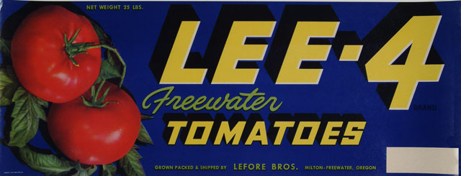http://collections.theautry.org/mwebcgi/mweb.exe?request=record;id=M518659;type=102
Object Name: crate label
Maker: Schmidt Lithograph Company
Title: Lee-4
Date: 1930s-1940s
Object ID: 93.202.81
Notes: Crate label advertising LEE-4 brand tomatoes, LeFore Borthers, Milton-Freewater, Oregon.
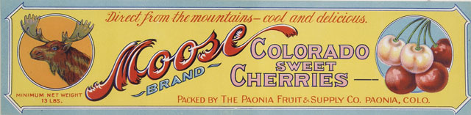http://collections.theautry.org/mwebcgi/mweb.exe?request=record;id=M502900;type=102
Object Name: crate label
Maker: United States of America (nation)
Title: Moose
Date: 1930s-1940s
Object ID: 93.202.36
Notes: Crate label advertising MOOSE brand cherries, Paonia Fruit and Supply Company, Paonia, Colorado.

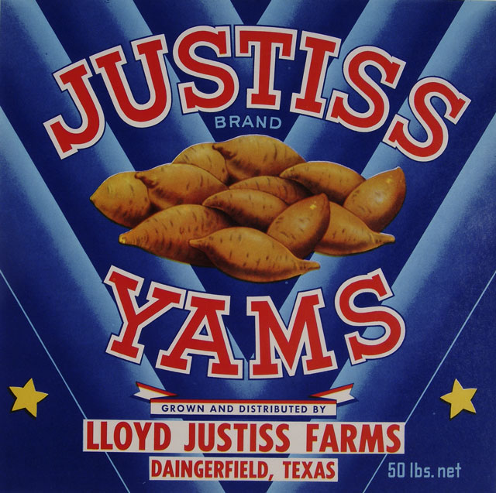http://collections.theautry.org/mwebcgi/mweb.exe?request=record;id=M511687;type=102
Object Name: crate label
Maker: United States of America (nation)
Title: Justiss
Date: 1930s-1940s
Object ID: 93.202.18
Notes: Crate label advertising JUSTISS brand yams, Lloyd Justiss Farms, Daingerfield, Texas.
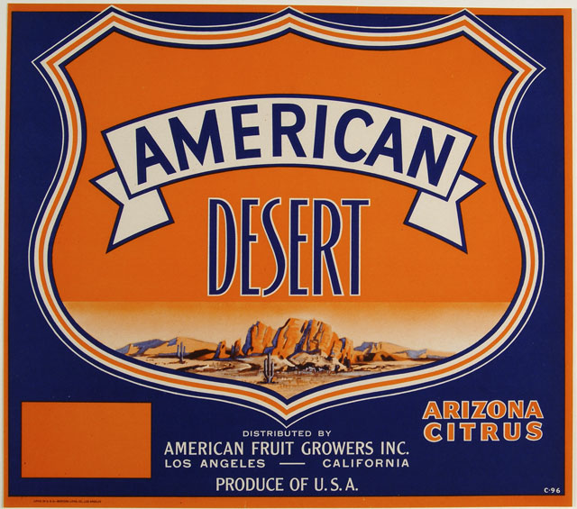http://collections.theautry.org/mwebcgi/mweb.exe?request=record;id=M524463;type=102
Object Name: crate label
Maker: Western Lithograph Company
Title: American Desert
Date: 1930s-1940s
Object ID: 91.170.11
Notes: Crate label advertising AMERICAN DESERT brand oranges, American Fruit Growers, Inc., Los Angeles, California.
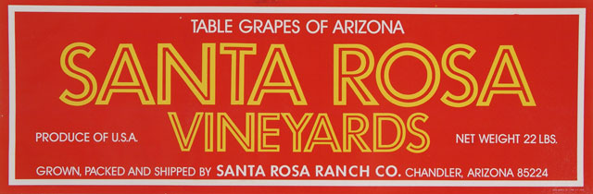http://collections.theautry.org/mwebcgi/mweb.exe?request=record;id=M529793;type=102
Object Name: crate label
Maker: Louis Roesch and Company
Title: Santa Rosa Vineyards
Date: 1940s-1950s
Object ID: 93.202.51
Notes: Crate label advertising SANTA ROSA VINEYARDS brand grapes, Santa Rosa Ranch Company, Chandler, Arizona.

